**VISVESVARAYA TECHNOLOGICAL UNIVERSITY**

**“JnanaSangama”, Belgaum -590014, Karnataka.**



**LAB REPORT**

**on**

Object Oriented Modelling and Design Lab(20CS6PCOMD)

***Submitted by***

Supriya M Lingdal(1BM20CS415)

***in partial fulfillment for the award of the degree of***

**BACHELOR OF ENGINEERING**

***in***

**COMPUTER SCIENCE AND ENGINEERING**



**B.M.S. COLLEGE OF ENGINEERING**

**(Autonomous Institution under VTU)**

**BENGALURU-560019**

**April-2022 to July-2022**

**B. M. S. College of Engineering,**

**Bull Temple Road, Bangalore 560019**

(Affiliated To Visvesvaraya Technological University, Belgaum)

**Department of Computer Science and Engineering**



**CERTIFICATE**

This is to certify that the Lab work entitled “Object Oriented Modeling and Design Lab” carried out by Supriya M Lingdal**(1BM20CS415),** who is bonafide student of **B. M. S. College of Engineering.** It is in partial fulfillment for the award of **Bachelor of Engineering in Computer Science and Engineering** of the Visvesvaraya Technological University, Belgaum during the academic year 2021-2022. The Lab report has been approved as it satisfies the academic requirements in respect of a **Object Oriented Modelling and Design Lab-(20CS6PCOMD)** work prescribed for the said degree.

Name of the Lab-Incharge **Dr. Jyothi S Nayak**

Designation Professor and Head

Department of CSE Department of CSE

BMSCE, Bengaluru BMSCE, Bengaluru

Index Sheet

|  |  |  |
| --- | --- | --- |
| **Sl.**  **No.** | **Experiment Title** | **Page No.** |
| 1 | College Information System |  |
| 2 | Hostel management System |  |
| 3 | Stock management System |  |
| 4 | Coffee Vending Machine |  |
| 5 | Online Shopping System |  |
| 6 | Railway Management System |  |
| 7 | Graphical Editor |  |

Course Outcome

**Ability to conduct practical experiment to solve a given problem using Unified Modeling language.**

**CO4**

Exercise1

College Information System

**Problem statement:**

Design UML diagrams for College Information System with system requirements specification.

**Software Requirements Specification (SRS):**

A centralized approach and system for managing, storing, accessing and updating all the information and details present in relevance to students, and teaching and non-teaching faculty, increasing efficiency and convenience of information management in educational institutions.

● Educational institutions should be able to add, edit and view student personal details, like name,age, gender, email, phone number, address and so on.

● Educational institutions should be able to add, edit and view student academic details, like USN, department, semester and registered courses.

● Faculty should be able to view all student personal details, and should be able to view and edit internal evaluation marks and attendance of students.

● The COE office should be able to view all student details, and view and edit internal and examination marks, and publish results.

● Placement section should be able to view all student details, and add companies coming to the campus for placements.

● Management section should be able to view, add and edit teaching and non-teaching staff details.

● Students should not be allowed to edit their personal or academic details.

● The system should be convenient and easy to use by students, management and faculty.

● The system should be a reliable source of information viewing (most importantly, academic grades) for students, COE and faculty.

Advanced Class Diagram of College Information System

The below shown class diagram contains the following classes: superAdmin, teacher, admin, course ,student ,librarian ,college ,book with multiplicities as shown.

Association:Admin manages teachers,teacher teaches courses,student returns books

Saff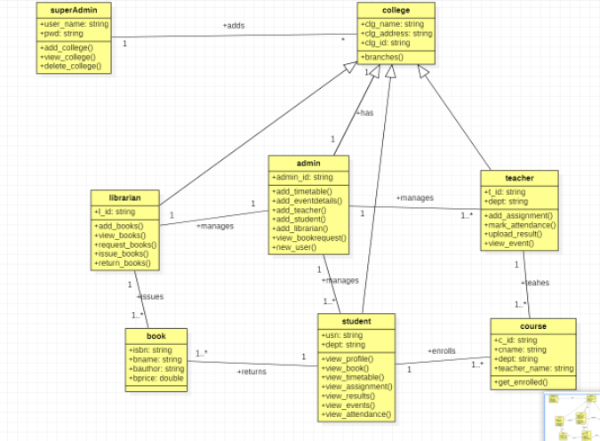

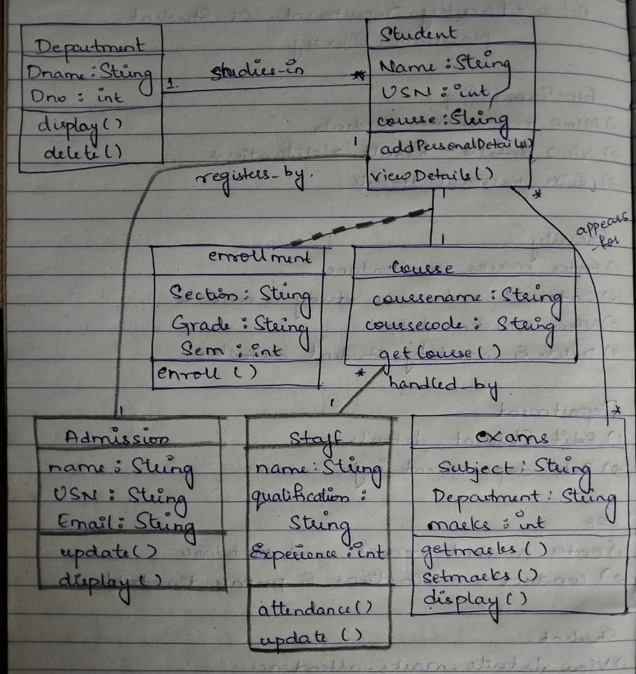

Advanced State Diagram of College Information System

The advanced state diagram depicted below contains one nested state and one submachine, which

on successful login shows the course details and procedure of student. It contains initial

state and termination state with generalization of fees in to exam fees,college fees,management fees

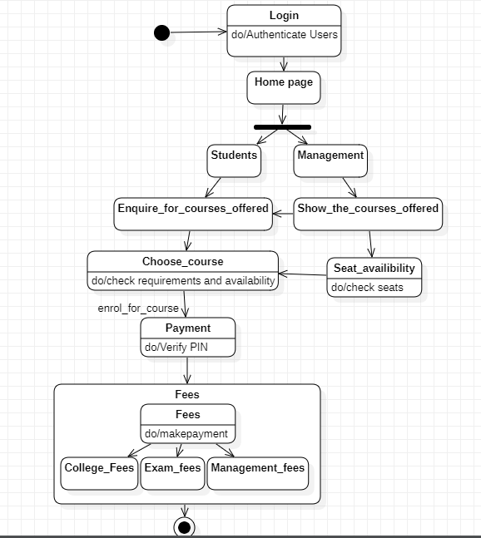

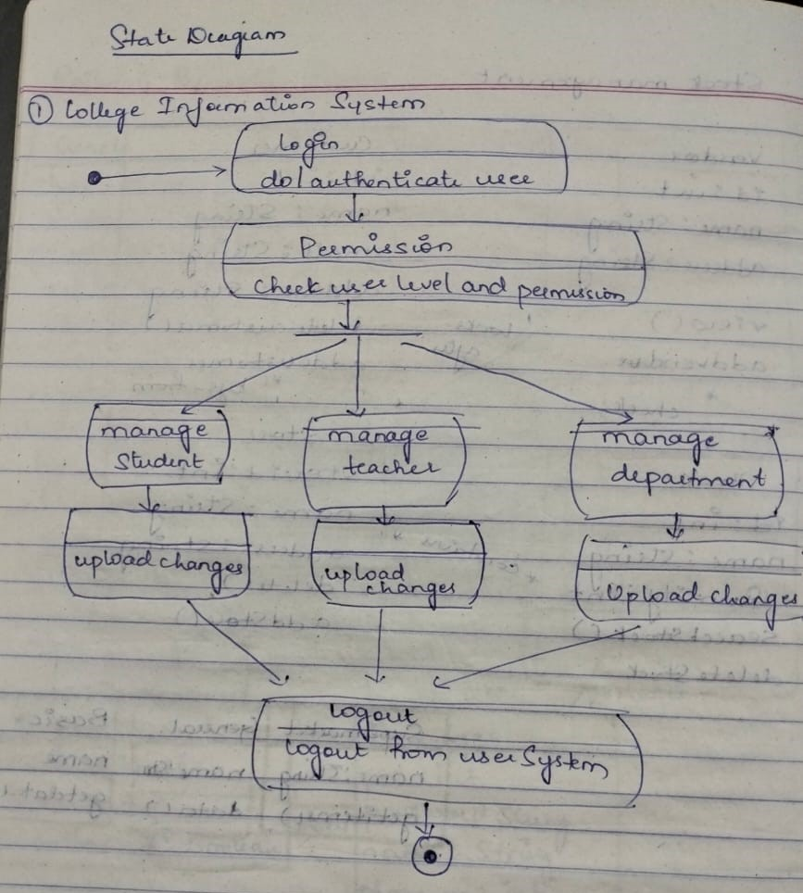

Advanced Use case Diagram of College Information System

The below usecase diagram has 3 actors namely admin,accountant and users-which is genaralized into students and faculty.Admin can login and manage the information my authenticating themselves. Users can view the information and register themself by providing the necessary info and take admission by paying the fees

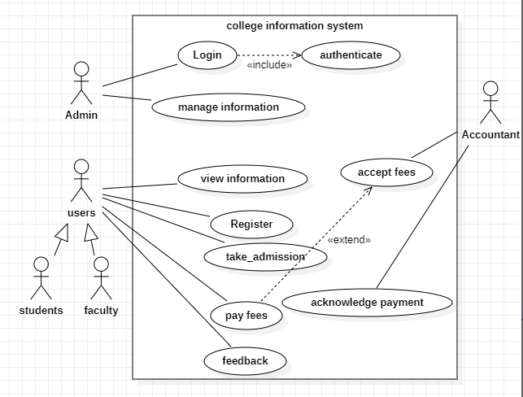

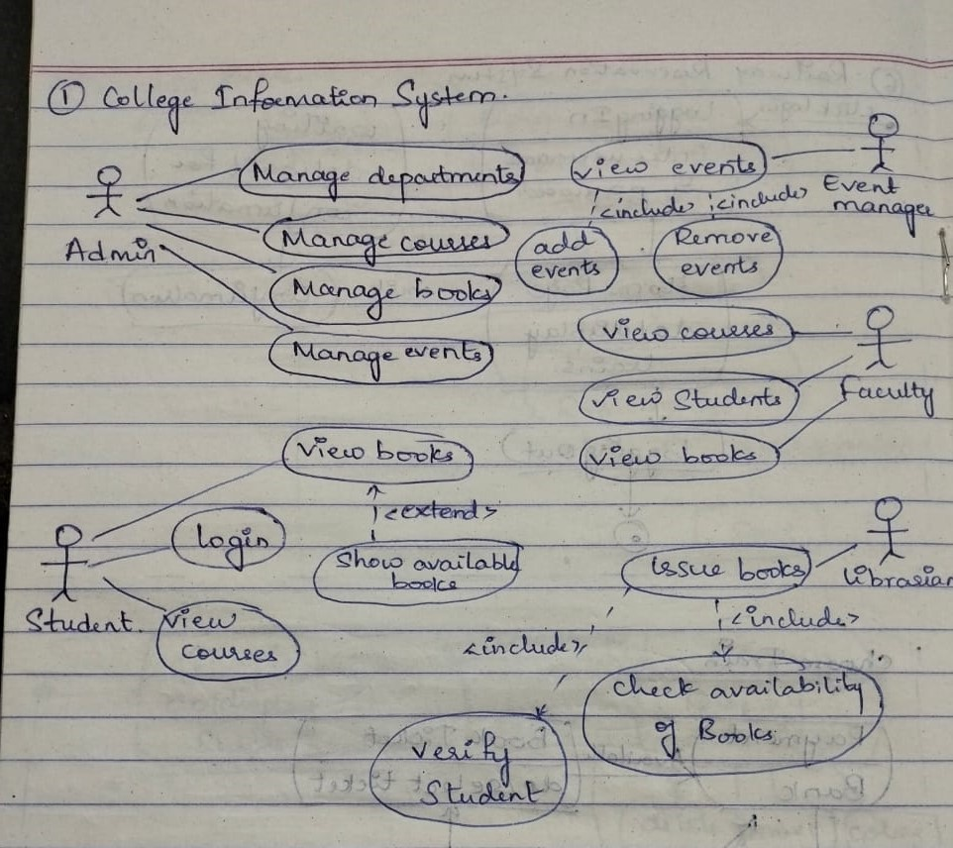

Advanced Sequence Diagram of College Information System

The sequence of steps that are carried out by the system.Student registers by giving his details and the information is saved in the database successfully.The users can view the information and for admission can check the availability and then enroll for the course of interest by paying the fees by validating themselves

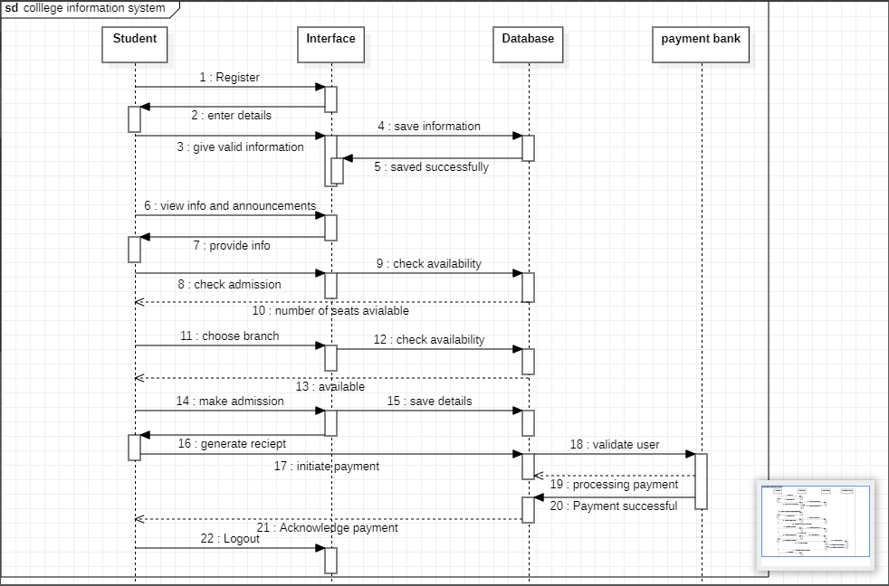

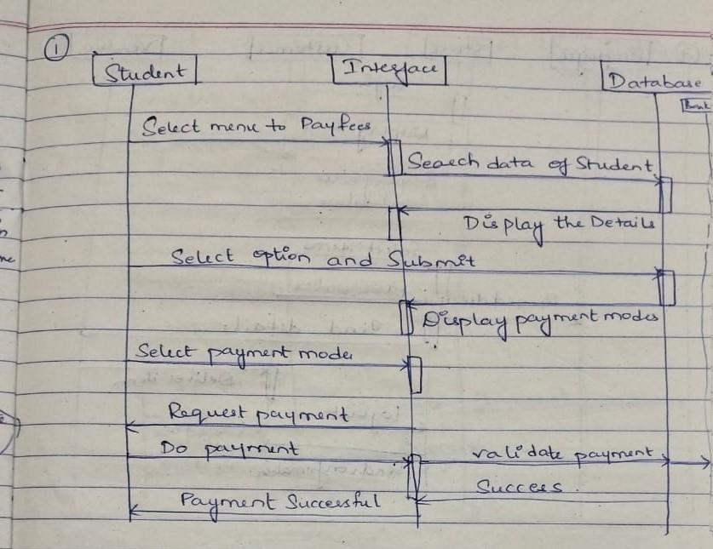

Advanced Activity Diagram of College Information System

In the below Activity diagram when student logs in by entering the valid information and later the validation is done while the student waits for the response to receive the confirmation then views the course list and selects the course and initiates the payment.The student information is stored in the database

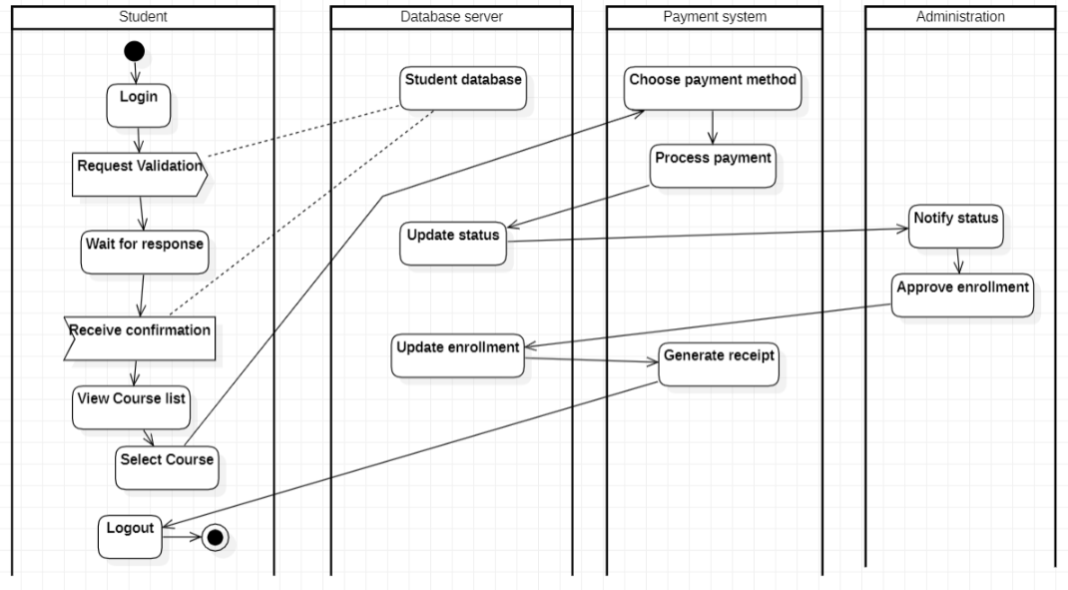

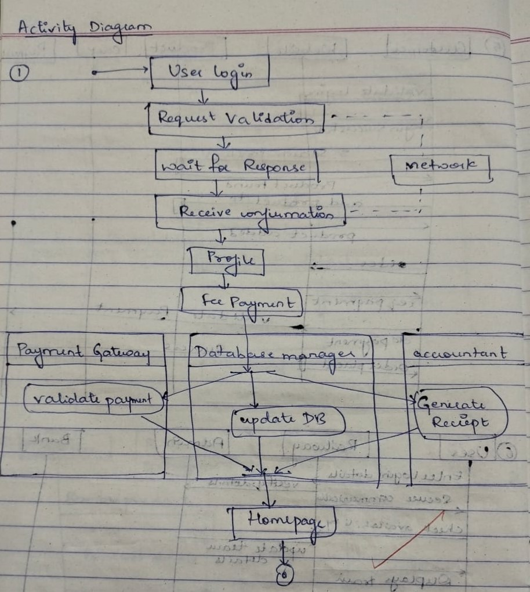

LAB 2

Hostel Management System

**Problem statement:**

Design UML diagrams for Hostel Management System with system requirements specification.

**Software Requirements Specification (SRS):**

The purpose of the Hostel Management System is to carry out different operations of a hostel. This

system will provide ease of use to the staff of the hostel by performing all work on computers. It

helps to manage student and staff records.

● Admin can login using credentials provided to him.

● Admin can allot room to students.

● Students can login using the credential provided and can give feedback about staff.

● Admin can review the feedback provided by students.

● Admin can appoint staff.

● Students can provide message feedback.

● Mess managers can review the mess feedback.

● Mess manager can update the menu list.

● Admin can assign work to staff members.

● The system should be easy to handle.

● System should give expected performance results.

● The response time should be small

Advanced Class diagram of Hostel Management System

Hostel management system includes admin who manages the hostel.Students register and book the room,where the room is allotted by the admin and the mess manager looks after the management of the mess.

The students can give feedback and can register the complaints which are viewed by the admin

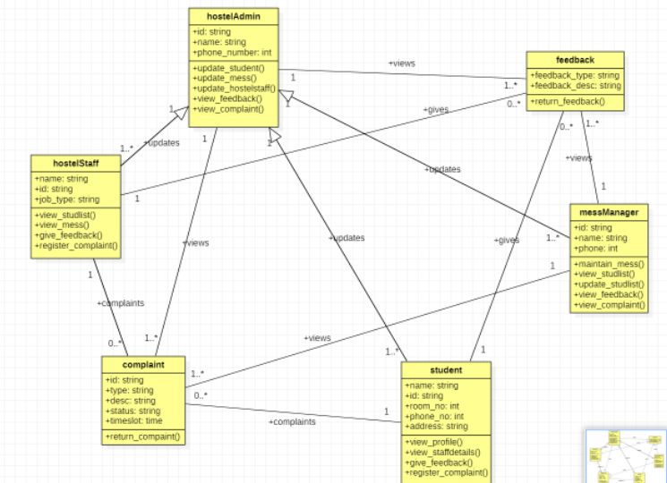

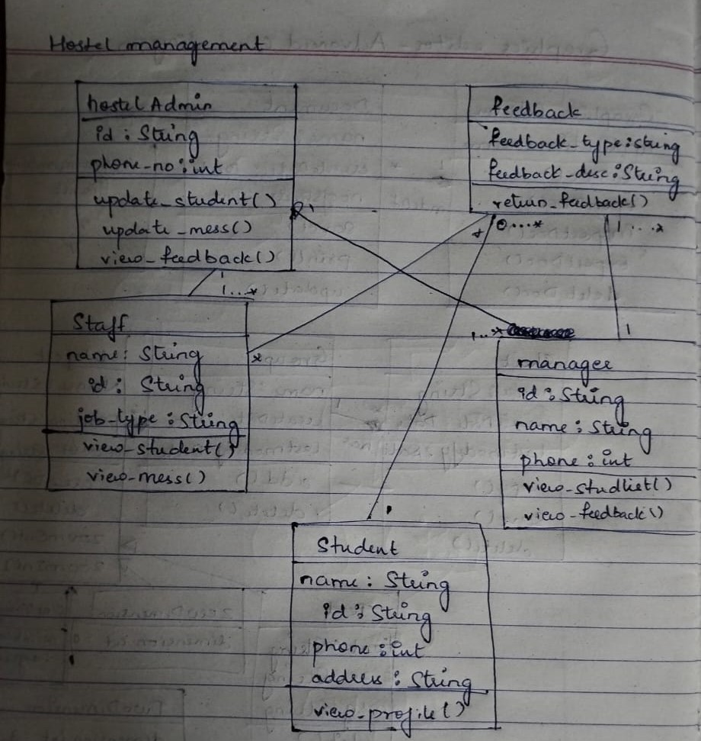

Advanced State Diagram of Hostel Management System

The flow of the procedure involved in hostel room registering and booking system is illustrated in below state diagram where the users login by authenticating themselves and if not registered yet then the users should provide their credentials and register.Students can check the available rooms and do the payment and reserve/book the rooms and later the room get allotted and the user logout

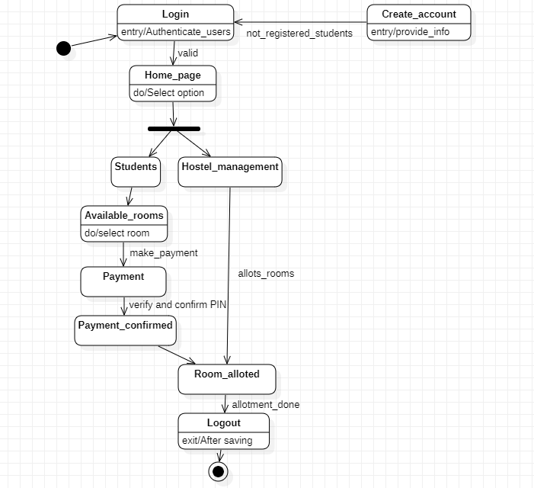

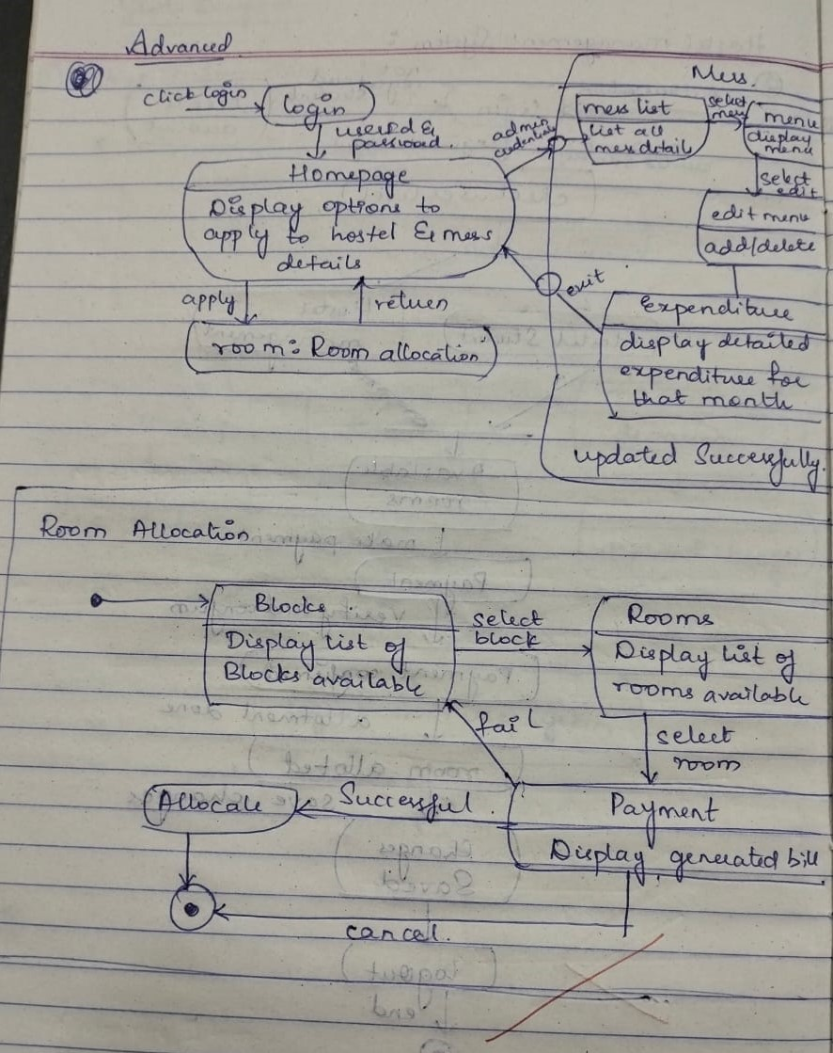

Advanced Use case Diagram of Hostel Management System

Here in the below diagram there are 4 actors namely admin,wardan,manager,student.Manager can be in different streams namely security,cleaning,mess.Student logs in by validating themselves and can update his student and staff .Admin allocates the rooms to the students.Wardan can view the details and can make and change the rules.Manager maintains the menu of the mess and looks after the security and the allotment of the hostel rooms

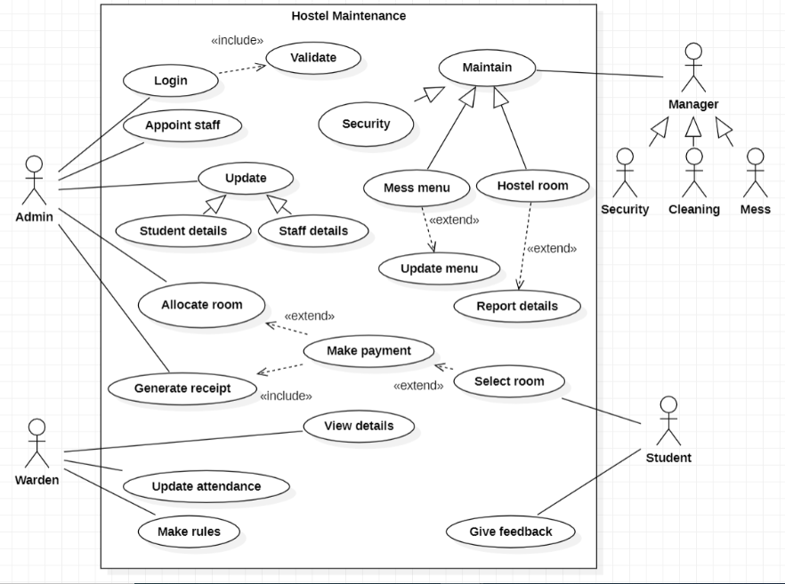

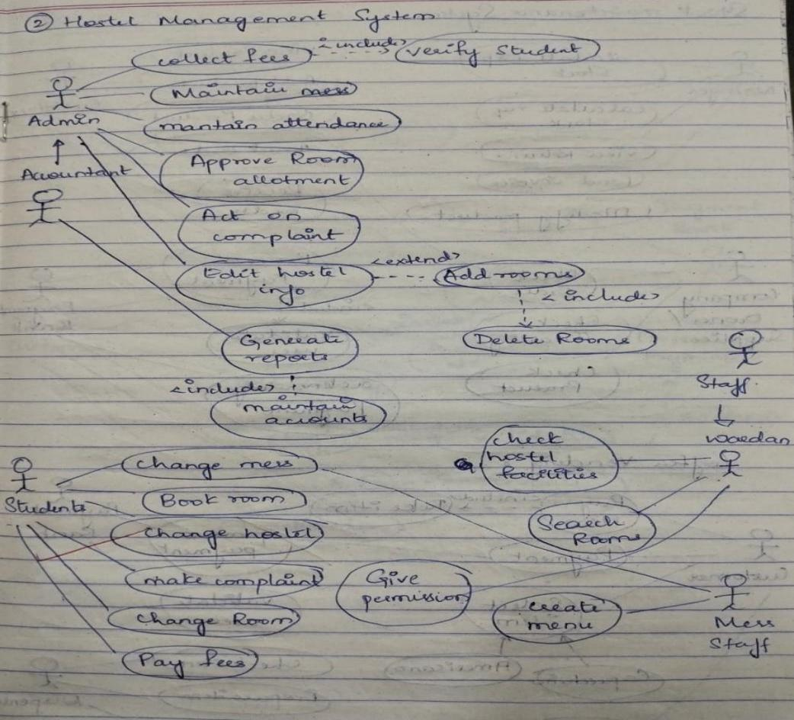

Advanced Sequence Diagram of Hostel Management System

This scenario illustrates the booking of the room by the student by initially logging in using the username and password and the validation is successful the students can request to check the availability of the rooms and then book the room by completing the payment procedure

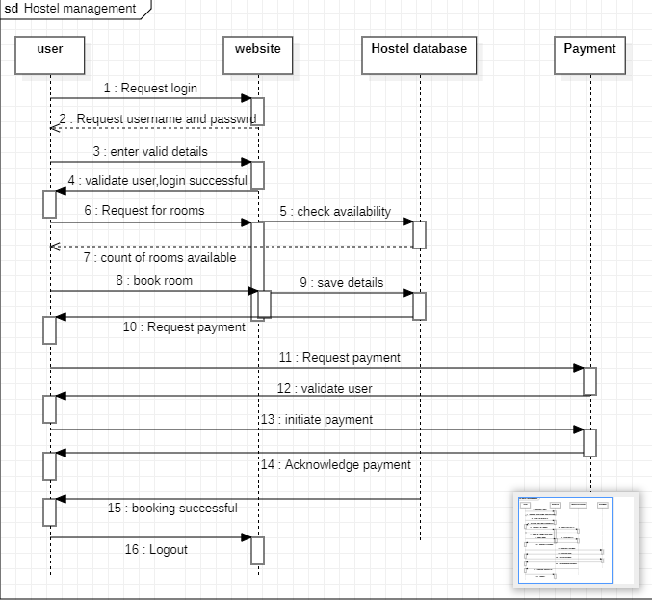

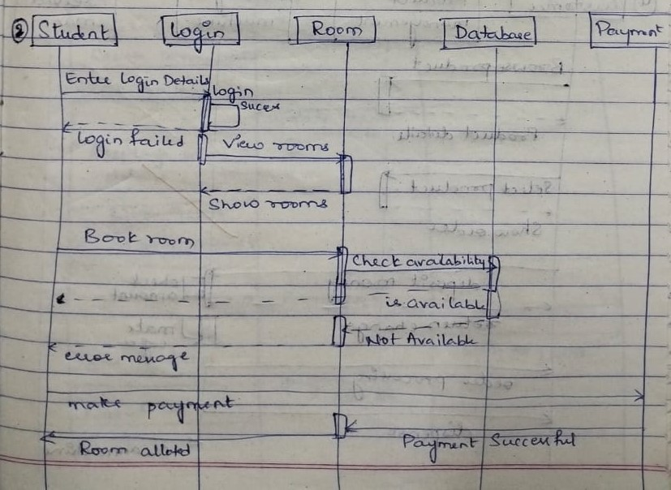

Advanced Activity Diagram of Hostel Management System

The below activity diagram shows us the procedure the student or the user should carry out to register for the hostel and book a room by gaining the information from the hostel website and select and book the room by doing the required payment

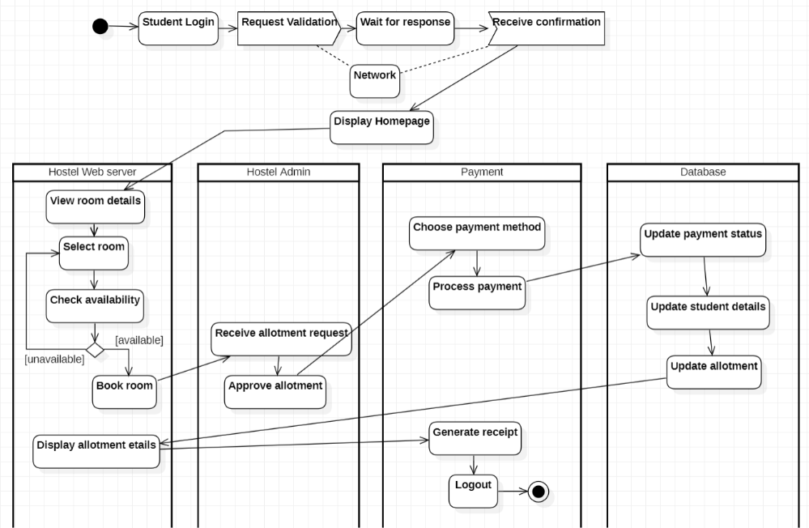

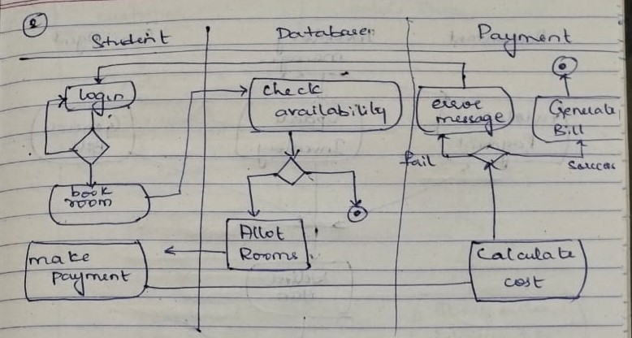

LAB 3

Stock Management System

**Problem statement:**

Design UML diagrams for Stock Maintenance System provided with system requirements specification.

**Software Requirements Specification (SRS):**

The stock maintenance system will allow the employees to record information of the items available in the store and generate reports based on the total amount of sales. The new system will have a windows-based desktop interface to allow employees to enter the information of sales, purchase orders, change employee preferences and create reports. The system retains information on all the items in the shop. The system retains the records of the cost, expiry date, vendor details, discount, quantity. The employee maintains the information of the sale of the item. He can add the items at the right time and update the database. The customer can view the availability of the required items and the price of the items. The customer can just view them but cannot make any changes.

The process of the stock maintenance system is that the customer logs in to the particular site to place the order for the customer product. The stock maintenance system is described sequentially

through steps

• The customer logs in to the particular site.

• They fill the customer details.

• They place the orders for their product.

• The vendor logs in and views the customer details and orders

Advanced Class Diagram of Stock Management System

The below shown class diagram contains the following classes: Role, Permisssion, Store, User, Stock, Product, Owner and Payment with multiplicities as shown.

Association: Owner buys Product, Owner buys Stocks, Owner pays Payment.

Generalization: User is generalized to Permission class and User is Generalized to Role.

Aggregation: Stock class, Product class, Store class, Owner class are (composed of) with

Permission class. Composition: Payment needs (or is composed of) Permission and Stock (or is composed of) has Product.

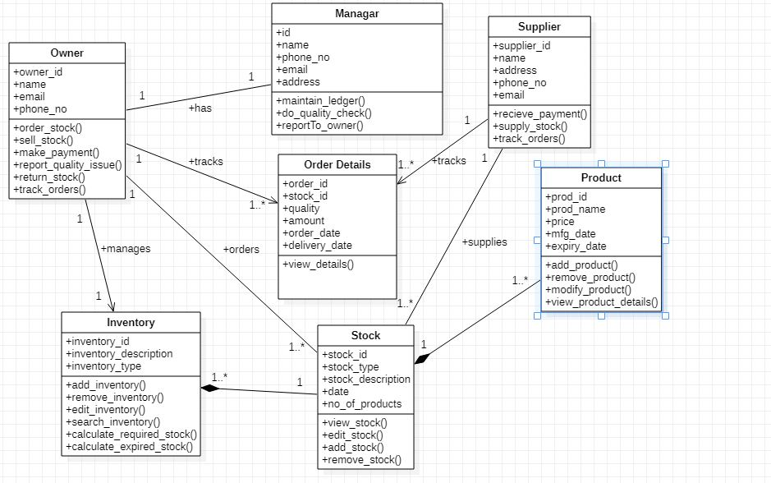

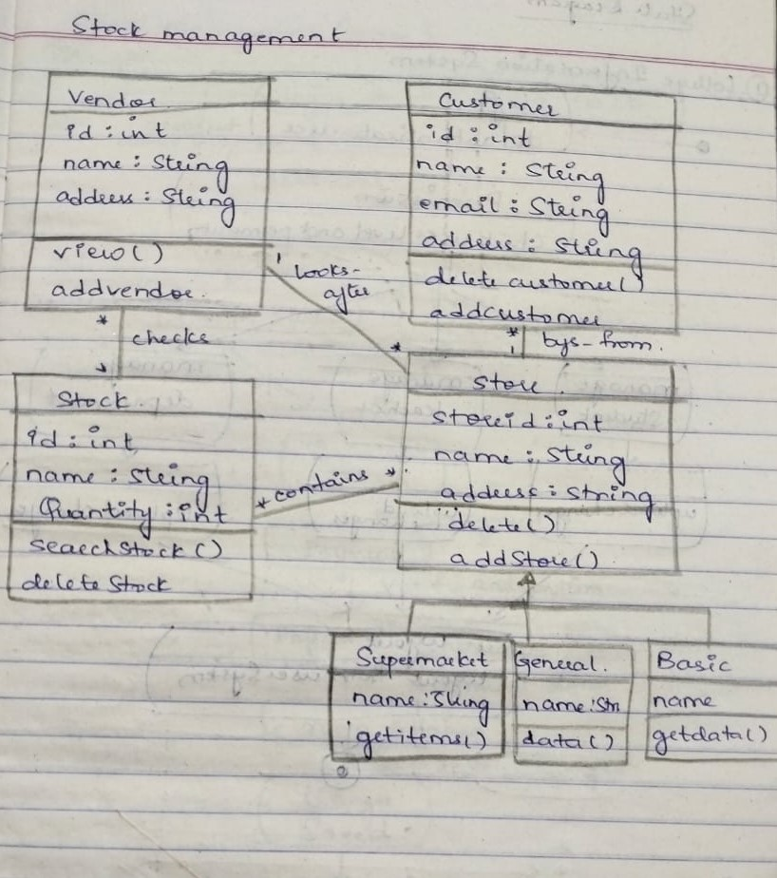

Advanced State Diagram of Stock Management System

The advanced state diagram depicted below contains one nested state and one submachine, which

on successful login shows the StockStatus details and StockPurchase procedure. It contains initial

state and termination state with Maintaining as a nested state including the required simple states.

It also has a submachine state named StockPurchase with initial, termination state along with simple

states; Inventory check, Sell, Payment, Validation.

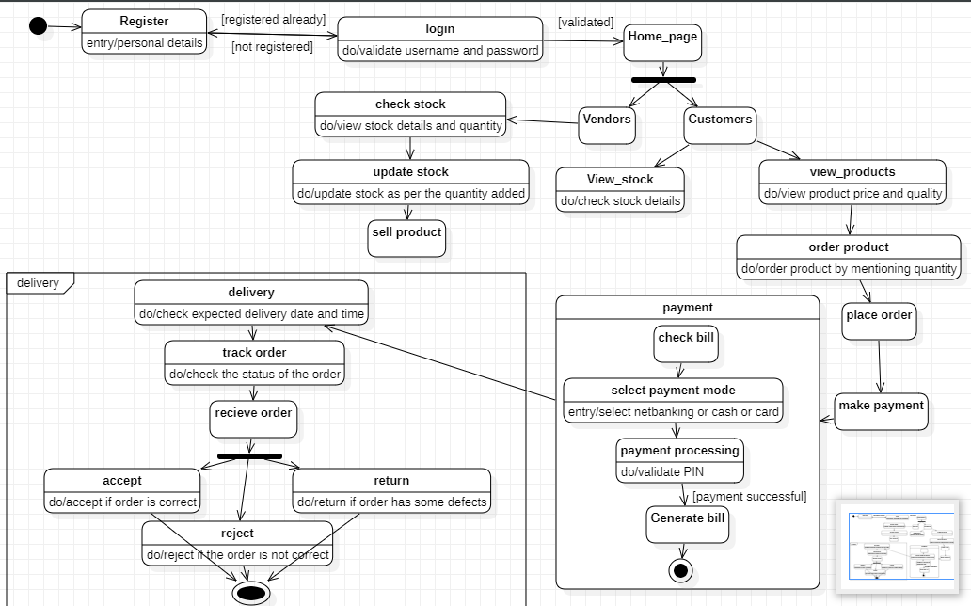

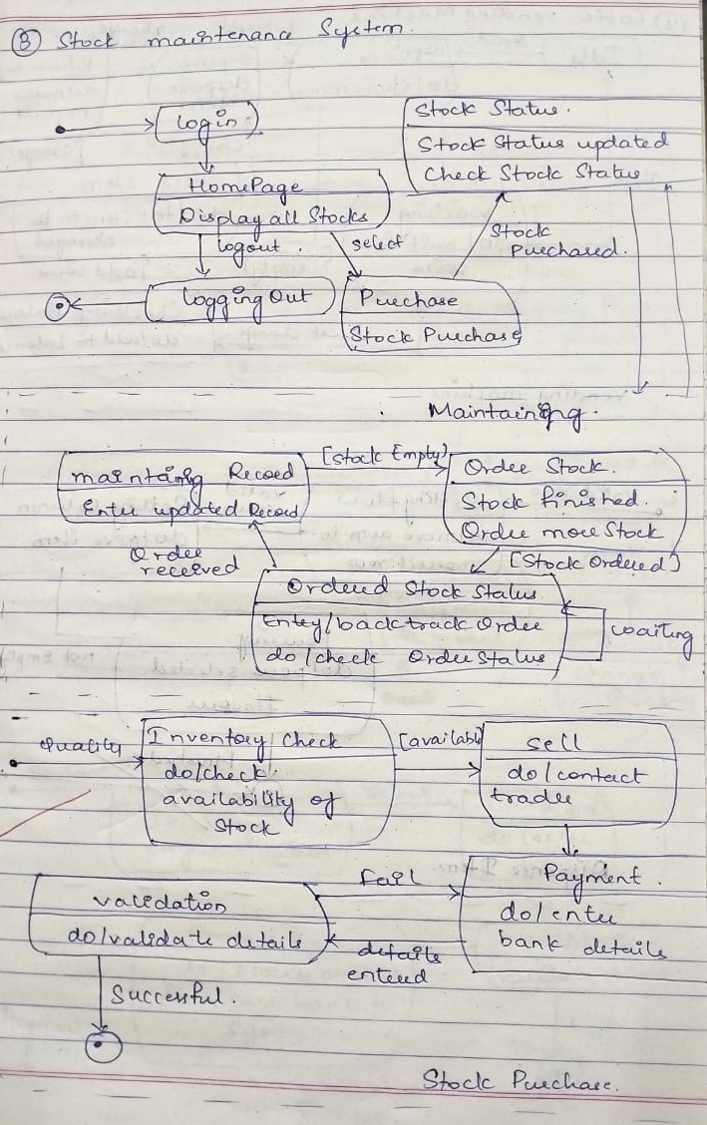

Advanced Use case Diagram of Stock Management System

The advanced use case diagram has extra functionalities which includes extends, includes and

generalization.The retailer can check the items and add them by managing the stocks.The customers can view,order,check price and quality of the item.The bank validates the user and processes the payment

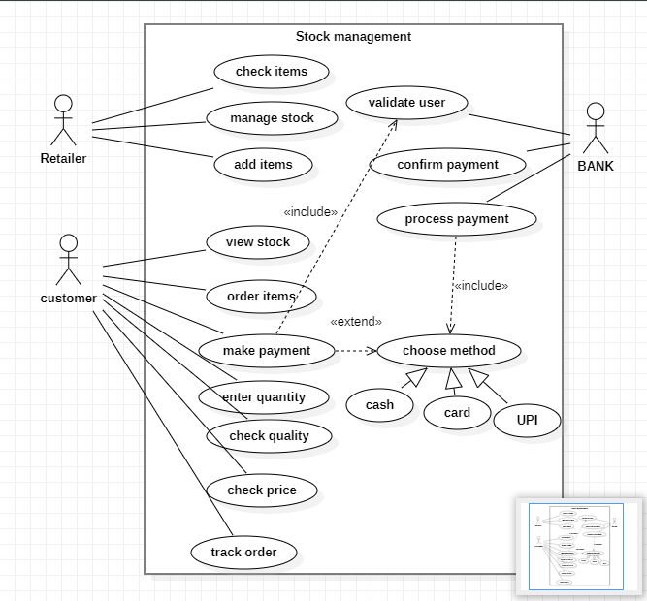

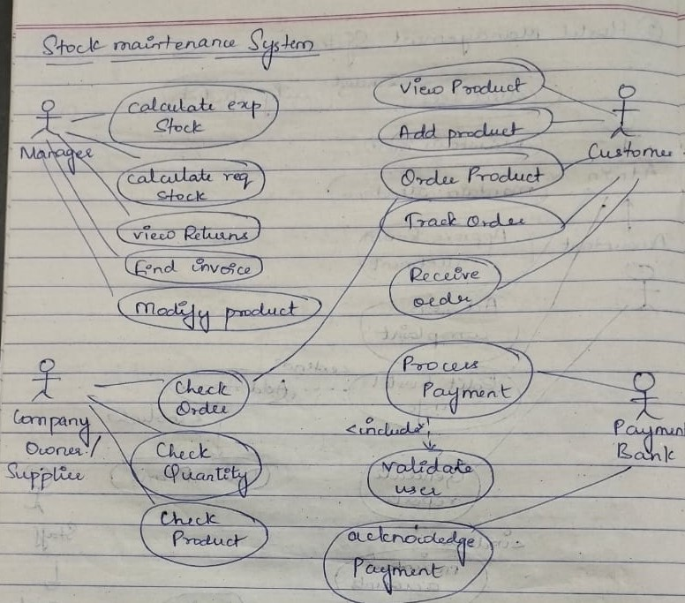

Advanced Sequence Diagram of Stock Management System

The lifeline is the dotted line and the rectangles represent the period of time the object is executing

and is hence called activation.

Create message signal is used to indicate the display of failure in any failure situation.

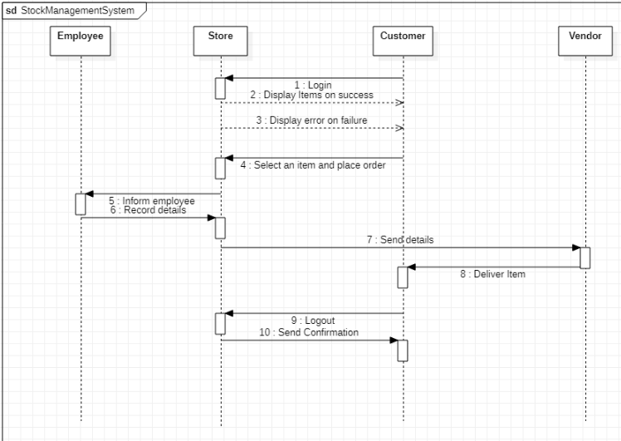

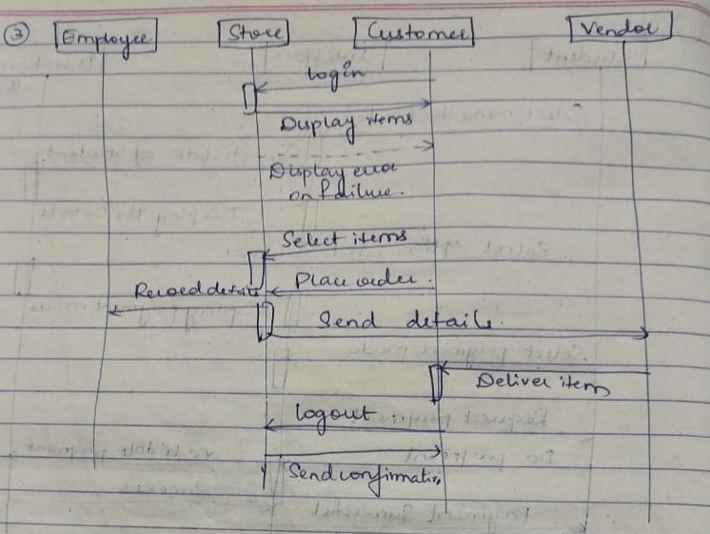

Advanced Activity Diagram of Stock Management System

The advanced activity diagram starts from initiation and then user login activity where a signal is

sent to the network for request validation and upon confirmation the control flows to order received

and then check inventory activity. There are three swimlanes namely inventory manager,

accountant and sale agent where update inventory, update payment and generate bill respectively.

Then the control flows to the home page and then termination activities

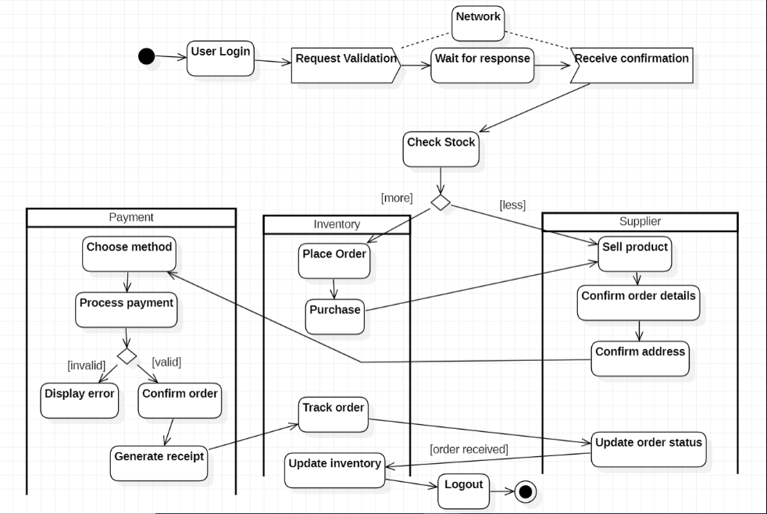

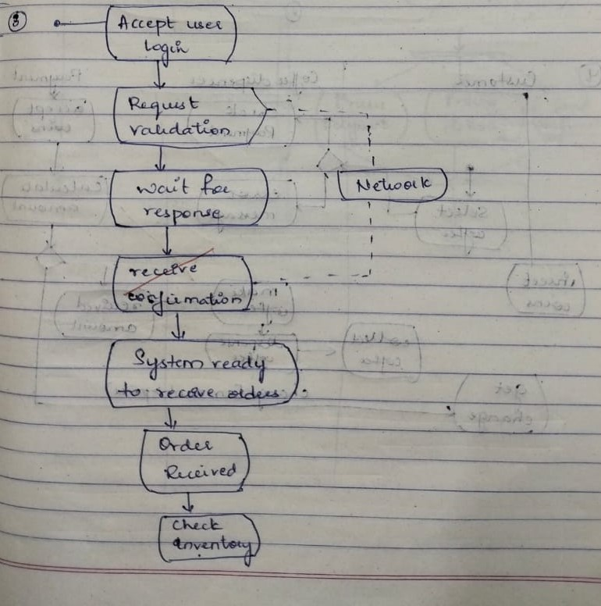

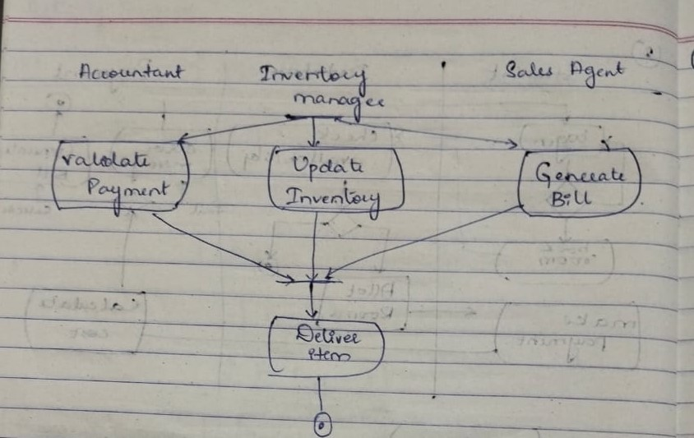

LAB 4

Coffee Vending Machine

**Problem statement:**

Design UML diagrams for Coffee Vending Machine with system requirements specification.

**Software Requirements Specification (SRS):**

The Objective of the system is to prepare a coffee vending machine for commercial purposes. The

system will be able to prepare coffee by processing all its required ingredients. Users will be

provided with sophisticated and easy to use user interfaces.

There are many different types of coffee makers using a number of different brewing principles, in

the most common devices, coffee grounds are placed in a paper or metal filter inside a funnel,

which is set over a glass or ceramic coffee pot, a cooking pot in the kettle family. Cold water is

poured into a separate chamber, which is then heated up to the boiling point, and directed into the

funnel.33

• Cash Box:Knows amount of money put in; Give change; Knows price of coffee; Turns front panel

on and off.

• Front panel:Captures selection; Knows what to mix in each; Instructs mixer when to mix.

• Mixer:Knows how to talk to the dispensers.

• Dispenser [cup-, coffee powder-, sugar-, creamer-, water-]:Knows how to dispense a fixed amount,

knows when it is empty.

Features:

• Small carbon footprint

• Energy saving advanced power management system

• Comprehensive drink range

• Simple user interface

Advanced Class Diagram of Coffee Vending Machine

The below shown class diagram contains the following classes: Coffee Machine, Cash Box,

Selector, Dispenser Register, Dispenser, Ingredient, Recipe, Product, Product Register. with

multiplicities as shown.

Association: Customer buys Product, Customer buys Stocks, Customer pays Payment.

Generalization: User is generalized to Permission class and User is Generalized to Role.

Aggregation: Coffee Machine contains Cash Box, Selectors, Dispense Register has Dispenser,

Dispenser is composed of Ingredients.

Composition: Recipe is made up of Ingredients

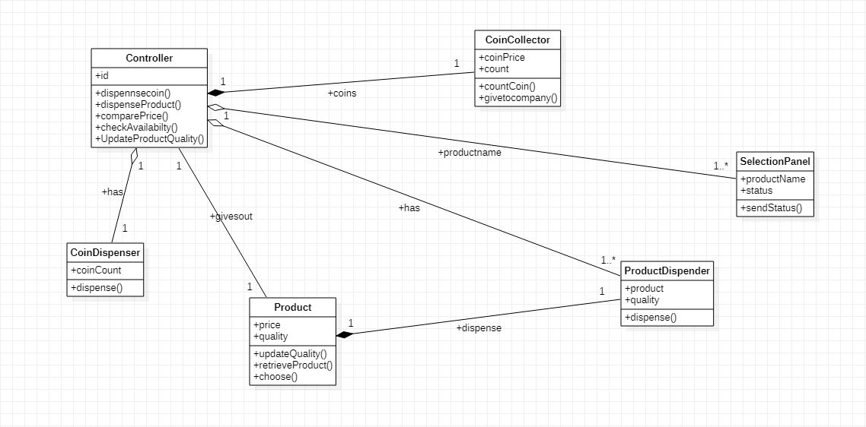

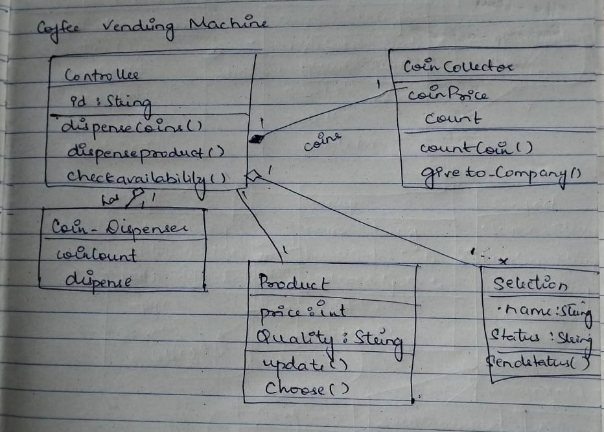

Advanced State Diagram of Coffee Vending Machine

The advanced state diagram depicted below contains one nested state and one submachine, which

on successful login shows the CollectingMoney procedure and DispenseItem procedure. It contains

initial state and termination state with CollectingMoney as a nested state including the required

simple states. It also has a submachine state named DispenseItem with initial, termination state

along with simple states; SettingRow, SettingColumn, Pouring

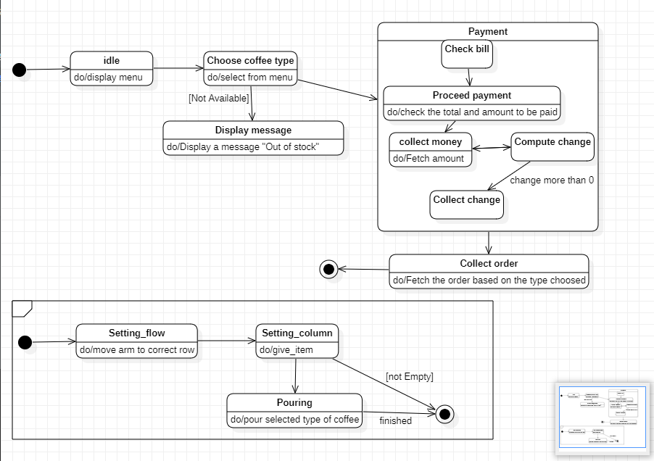

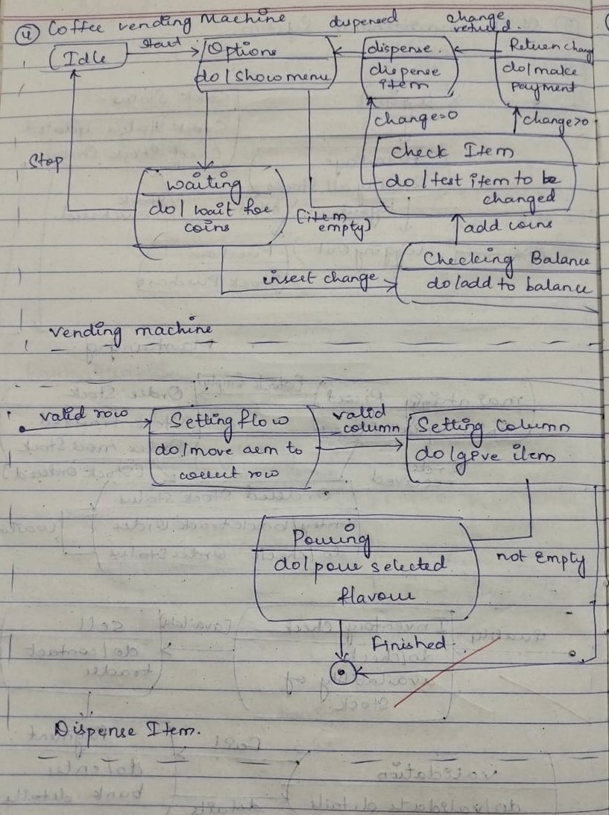

Advanced Use case Diagram of Coffee Vending Machine

The advanced use case diagram has extra functionalities which includes extends, includes and

generalization. The dispense change use case extends payment use case, payment use case extends

buy item use case, buy item use case includes choose item and take item use case. Capucchino

dispense and American dispense is generalized to super class dispense coffee.

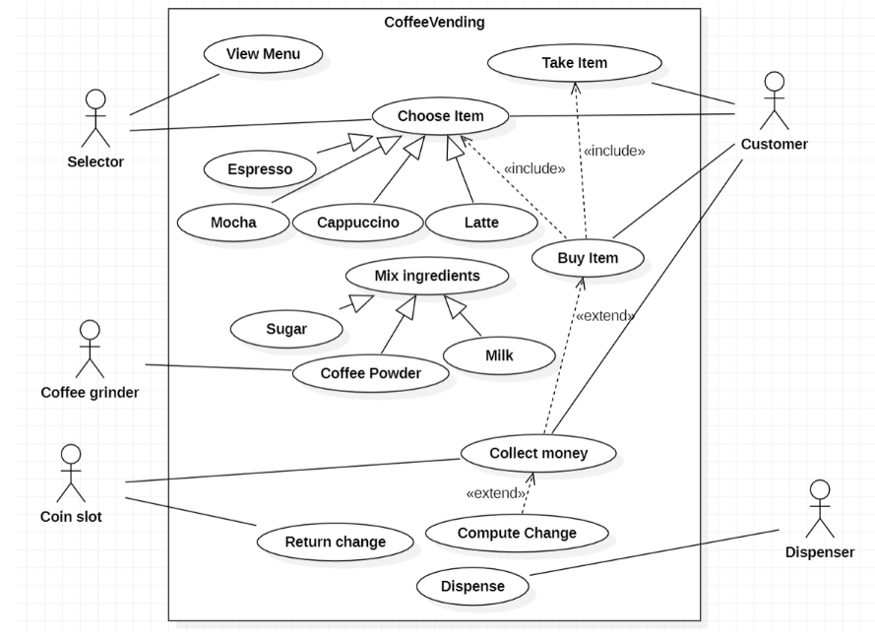

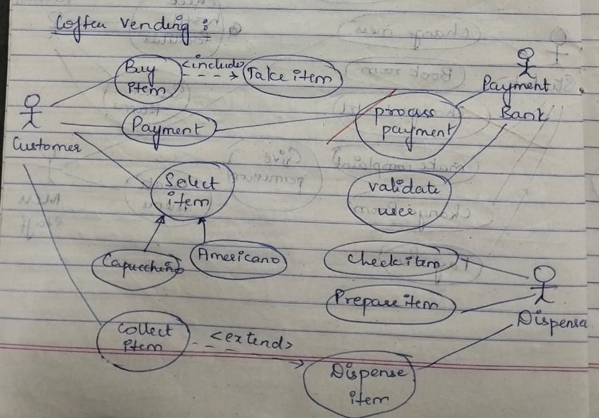

Advanced Sequence Diagram of Coffee Vending Machine

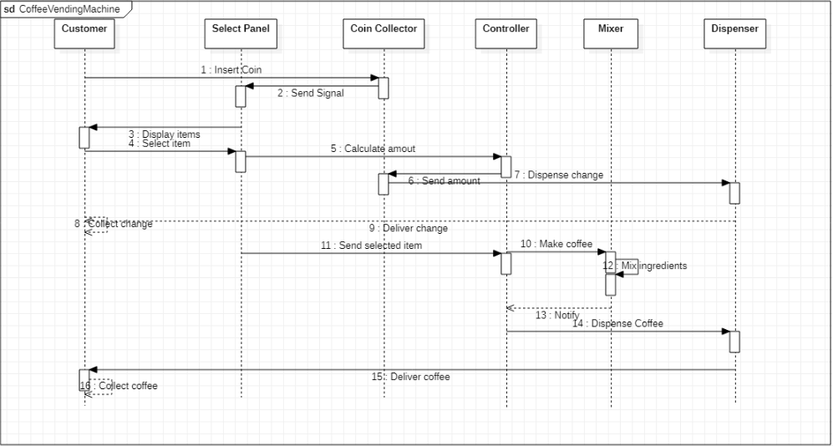

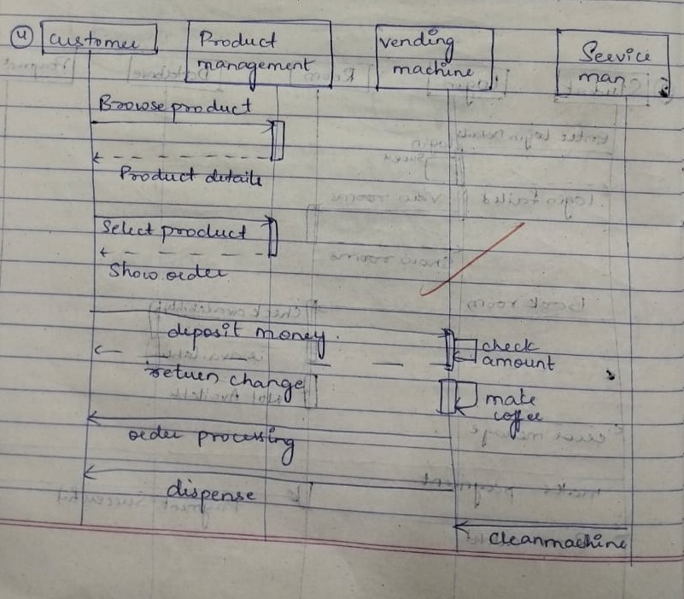

Advanced Activity Diagram of Coffee Vending Machine

The advanced activity diagram starts from initiation and in the customer swimlane, customer login

activity where a signal is sent to the network for request validation and upon confirmation the

control flowsto order received and then check inventory activity. There are three swimlanes namely

customer, coffee dispenser and payment where customer perform operations like order coffee,

dispenses coffee and collect coins respectively. Then the control flows to the home page and then

termination activities.

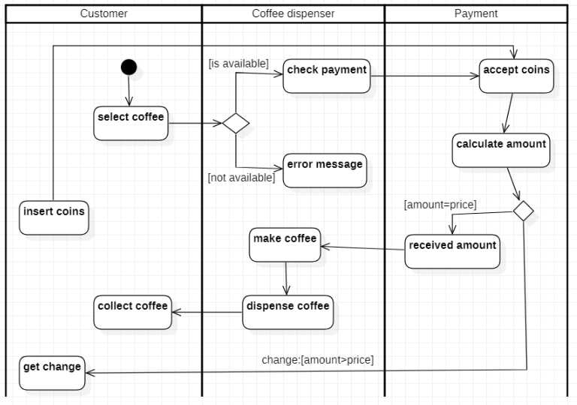

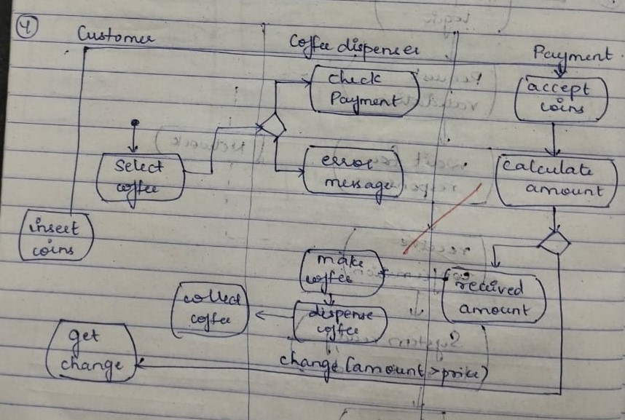

LAB 5

Online Shopping System

**Problem statement:**

Design UML diagrams for Online Shopping System with system requirements specification.

**Software Requirements Specification (SRS):**

The online shopping system allows the users and vendors to exchange products remotely and

reduces the amount of cost and time substantially. The software provides the following facilities to

the customers:

• Facilitates easy shopping online anywhere with free shipping (conditions apply).

• Provides information about the products in categories

• Can avail the facility of purchasing second hand products

• Can reserve if the particular product is not available

• Customers are provided with up to date information on the products available

• Provides email facility for future correspondence

• Provides backup facility

• Can add nearly ten products to their shopping cart at a time

The software will not provide the following facilities to the customers:

• Cannot reserve the product for more than two days.

• Cannot reserve more than two products

• Responsibility of damages

• The product cannot be changeable once confirmed

The software provides the following facilities to the merchants:

• Facilitates easy bidding facility

• Provides complete information about the customers

• Provides complete information about their products

• Can avail the facility of email correspondence and avail the brand catalog facility

Advanced Class Diagram of Online Shopping System

In the diagram below the users are the customers and the admin.The customer can add the products in to cart and they can order the items or the products.The product ordered has the order details and the shipping info which is visible to the users for reference

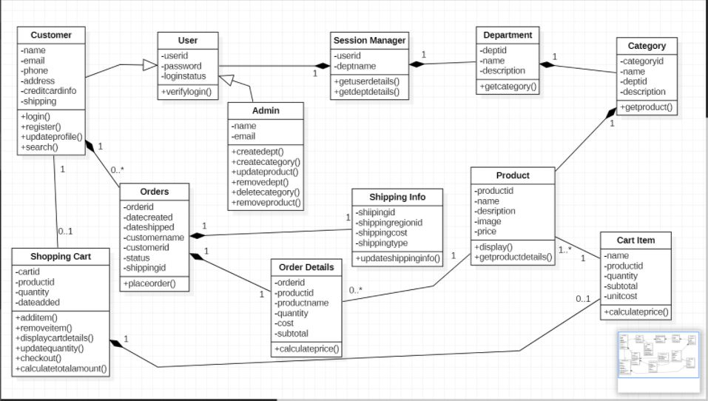

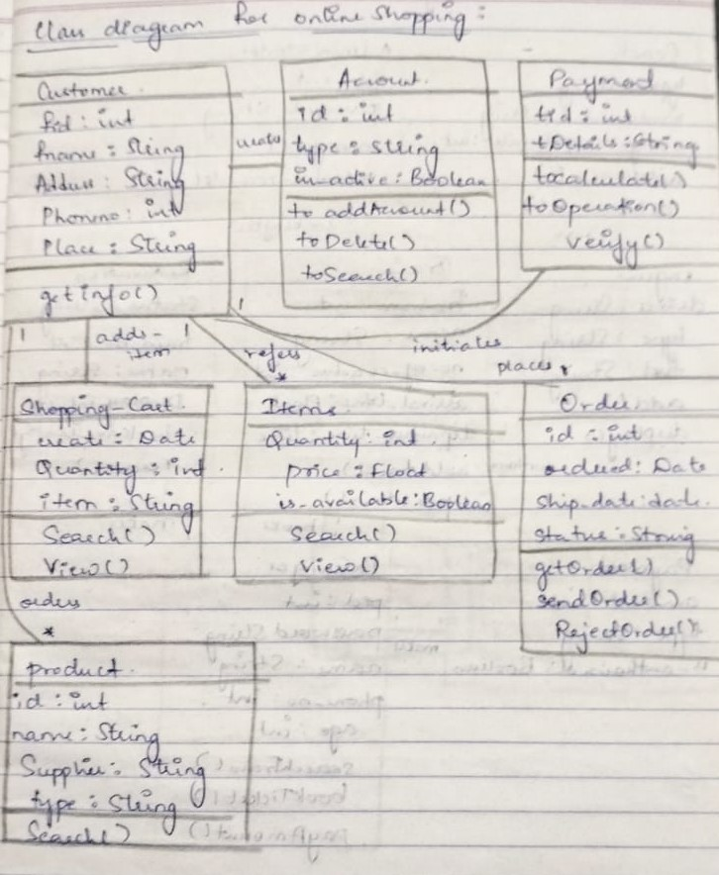

Advanced State Diagram of Online Shopping System

The state diagram below depicts the process of ordering a product until the receiving of the products by the customers.The customers login to the website to view the products or the cart or the orders placed.The users can view the product and add to the cart and then place the order by initiating the payment through the bank by validating themselves and then track the order placed,and after the order is received by the users the users have the option of return,replace or reject the order

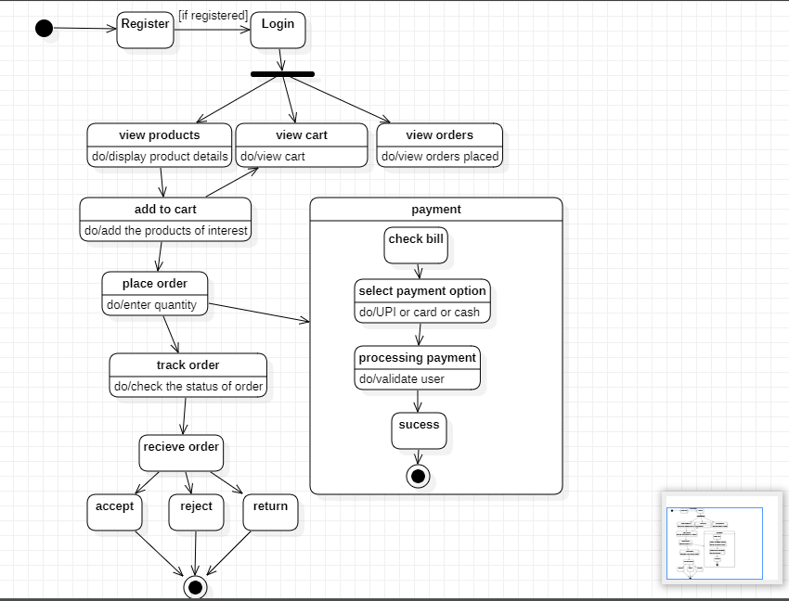

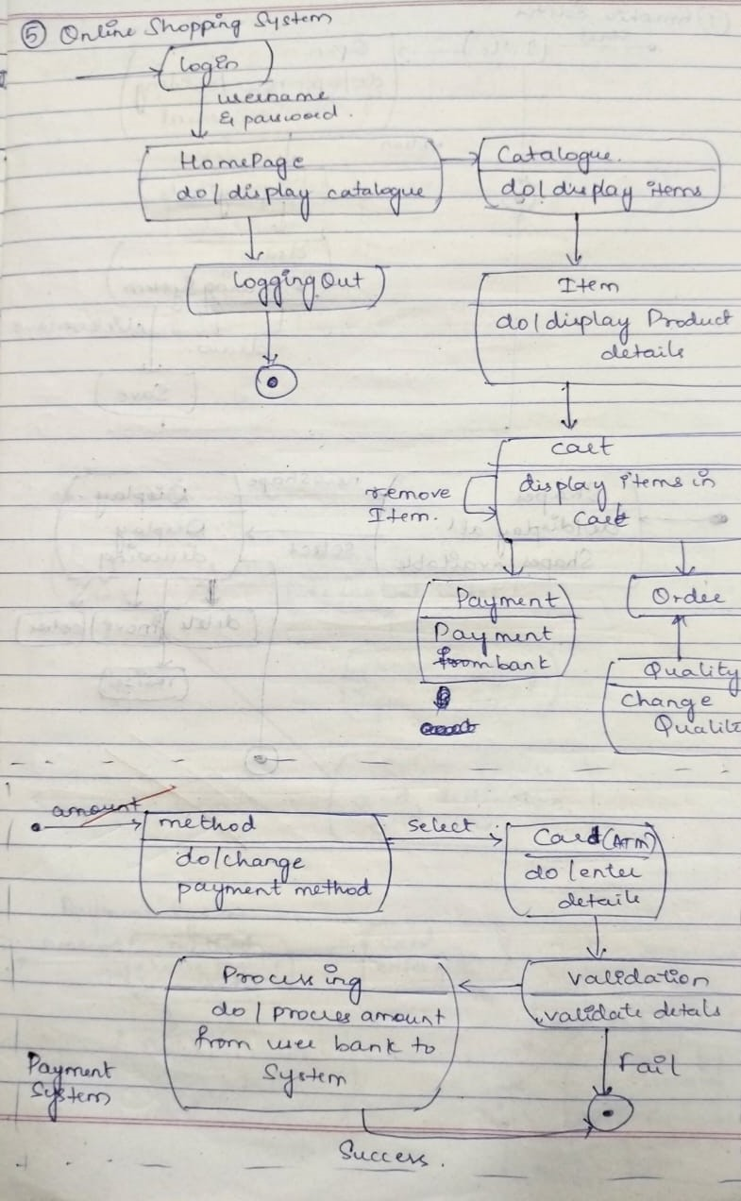

Advanced Use case Diagram of Online Shopping System

The above use case diagram has 3 actors namely the payment system,customer and the delivery system.Customers view catalog and see the items and order the items by payment and the bank system looks after the validation of the user and initiate the payment and proceed the order and the delivery system looks after the shipment and the delivery of the product to the valid customer on time

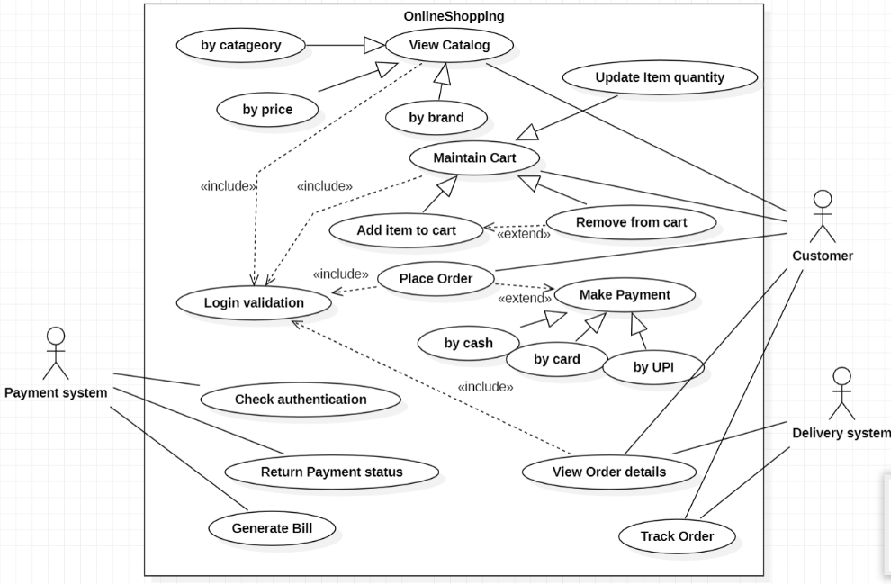

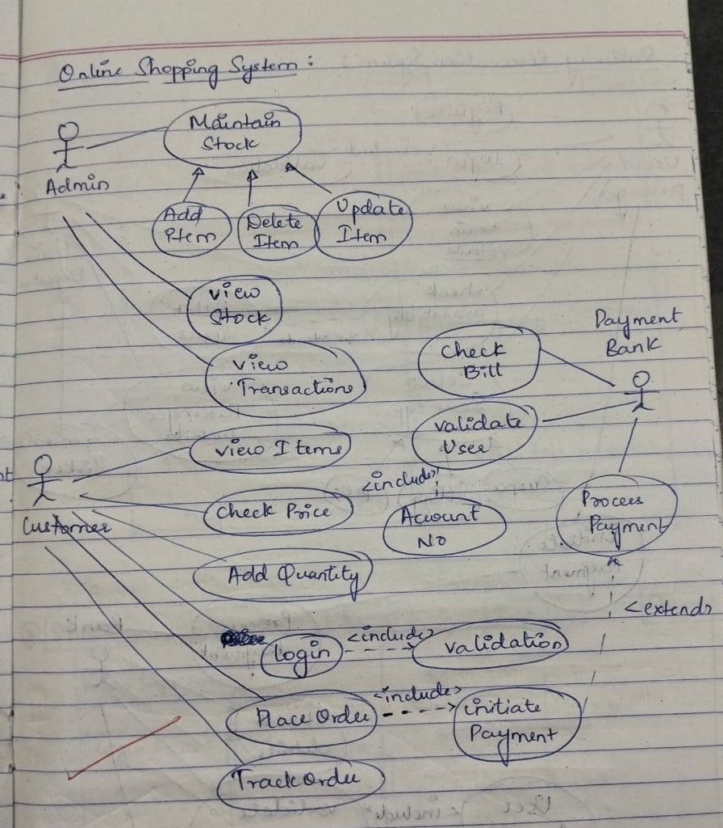

Advanced Sequence Diagram of Online Shopping System

The lifeline is the dotted line and the rectangles represent the period of time the object is executing

and is hence called activation.

Reply message is used to to return back to lifelines with the required message.

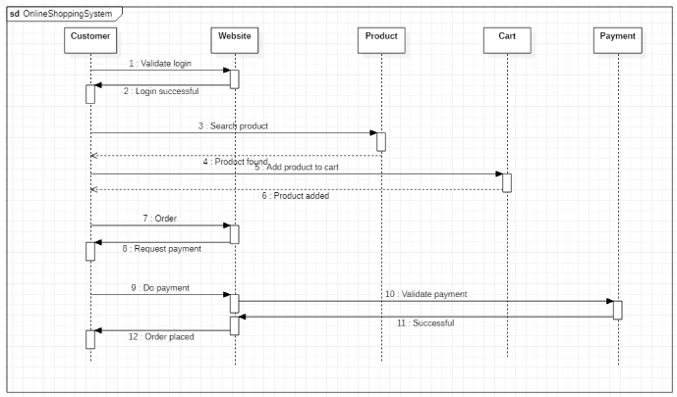

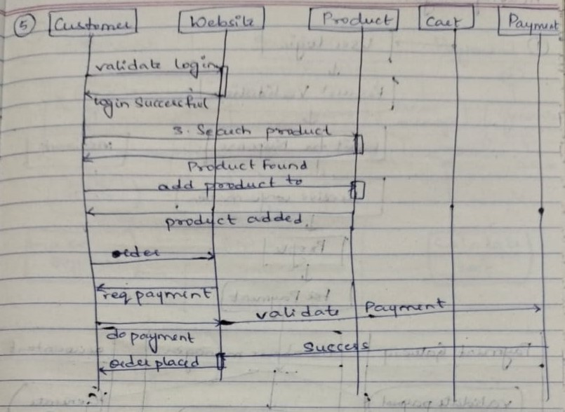

Advanced Activity Diagram of Online Shopping System

The advanced activity diagram starts from initiation and in the customer swimlane, the customer

login activity where a signal is sent to the network for request validation and upon confirmation the

control flows to add product and checkout activity. There are two swimlanes namely customer and

online shop where it confirms the order and delivery, payment process respectively. Then the

control flows to the home page and then termination activities

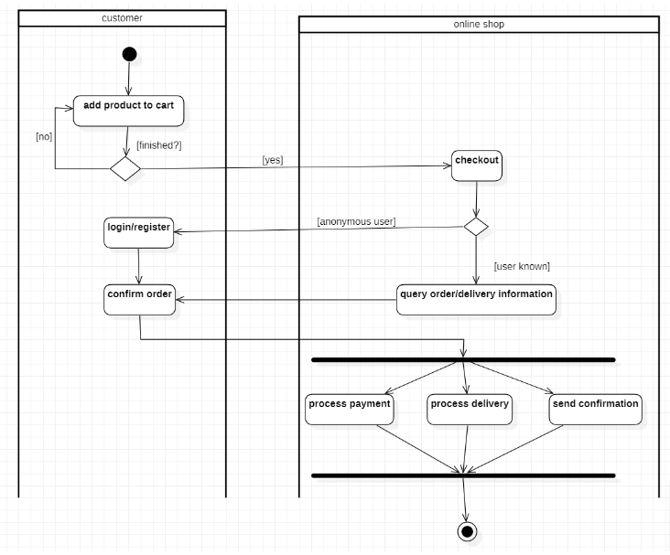

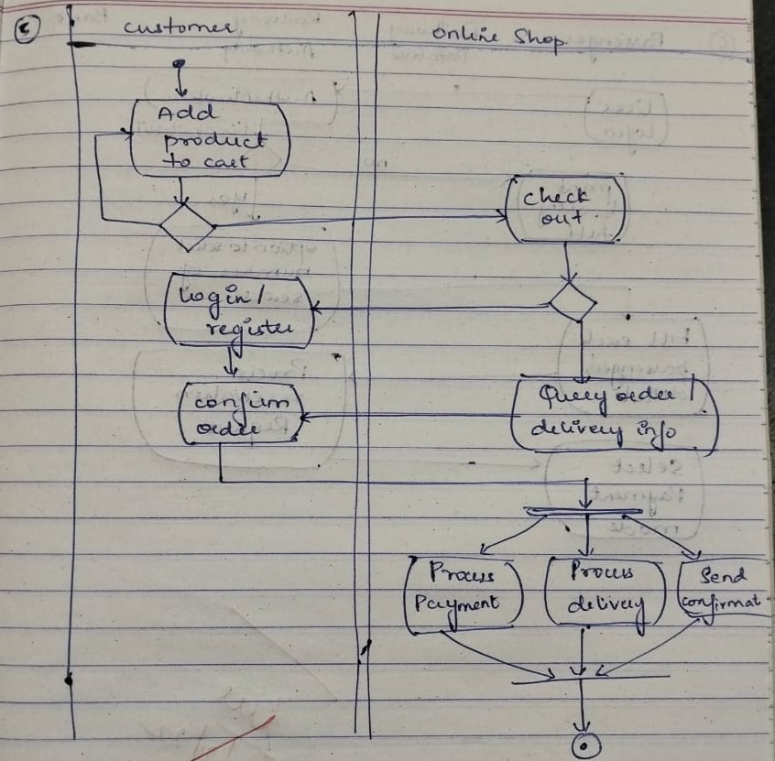

LAB 6

Railway Reservation System

**Problem statement:**

Design UML diagrams for Railway Reservation System with system requirements specification.

**Software Requirements Specification (SRS):**

To develop a user-friendly Railway Reservation System to enable passengers to book tickets online

and make payment online as well. Railway reservation system project which provides the train

timing details, reservation, billing and cancellation on various types of reservation namely,

• Confirm Reservation for Seat.

• Reservation against Cancellation.

• Waiting list Reservation.

• Online Reservation.

• Tatkal Reservation

This system enables the Advance booking in any class, against general and ladies quota, on payment

of fare in full for adults and children, a maximum of six berths/seats at a time, for journey between

any two stations served by a train. It also provides details about

1. Timetable

2. Train Fares

3. Current status of reservation position

4. Train available between a pair of stations

5. Accommodation available for a train/date combination Types of tickets: General and Tatkaal

Advanced Class Diagram of Railway Reservation System

The below shown class diagram contains the following classes: RailwayStation, Train, Admin,

Passenger, TicketBooking, Payment, Ticket, General and Tatkal with multiplicities as shown.

Association: Passengers takes Train, Admin supervises TicketBokking, TicketBooking pays Payment.

Generalization: General and Tatkal are generalized to Ticket class.

Association class: Bank with TicketBooking and Payment

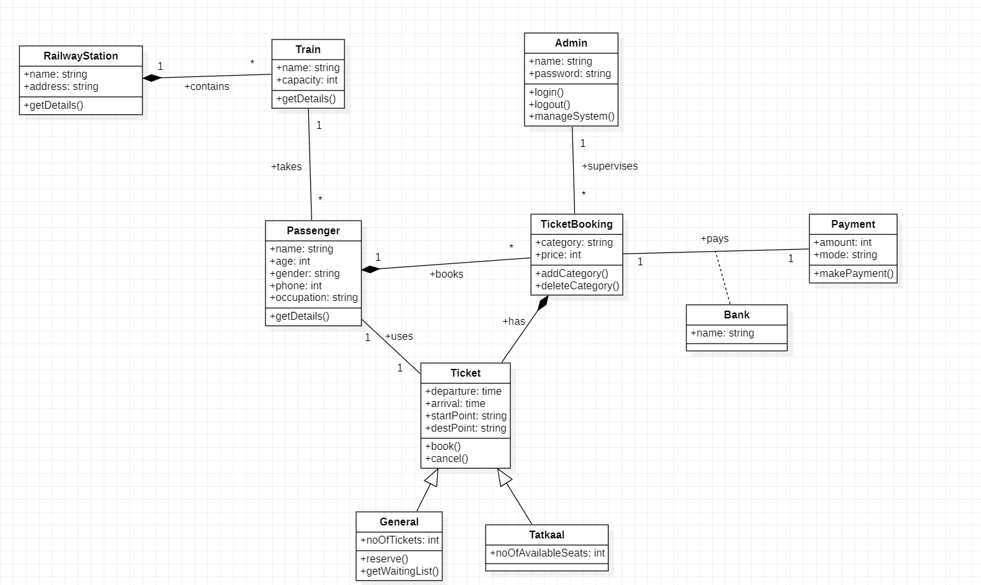

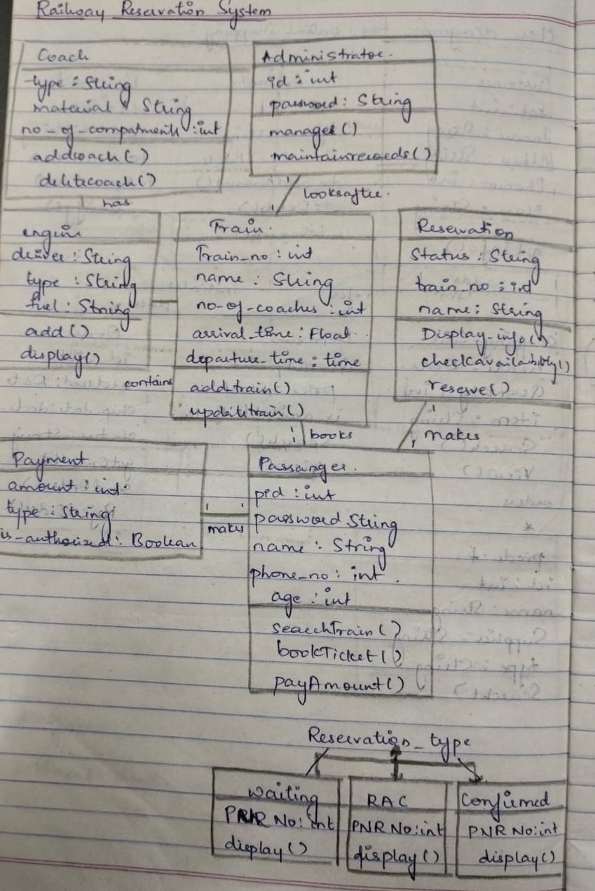

Advanced State Diagram of Railway Reservation System

The advanced state diagram depicted below contains one nested state and one submachine.The payment initiation includes the pay and the seats.It depicts that the payment and blocking/reservation of the seats happen at the same time.The payment includes validating of the user and the proceed

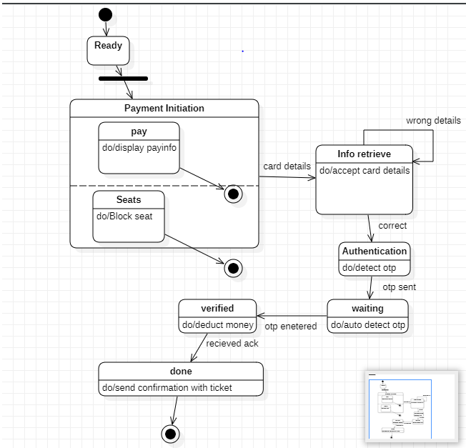

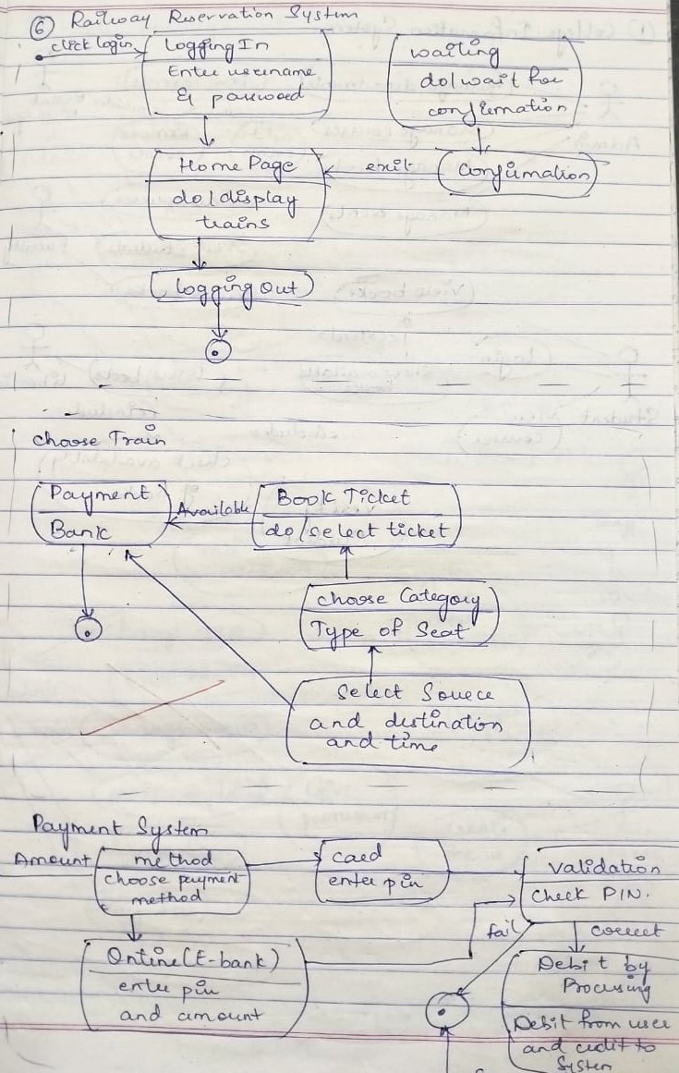

Advanced Use case Diagram of Railway Reservation System

The advanced use case diagram has extra functionalities which includes extends, includes and

generalization.The user can login and check the profile and check the train details and the PNR status and the availability of the seats for reservation in the train.The admin reserves the seats and can cancel booking. The make payment usecase has the feature of generalization which is divided into card,cash and UPI

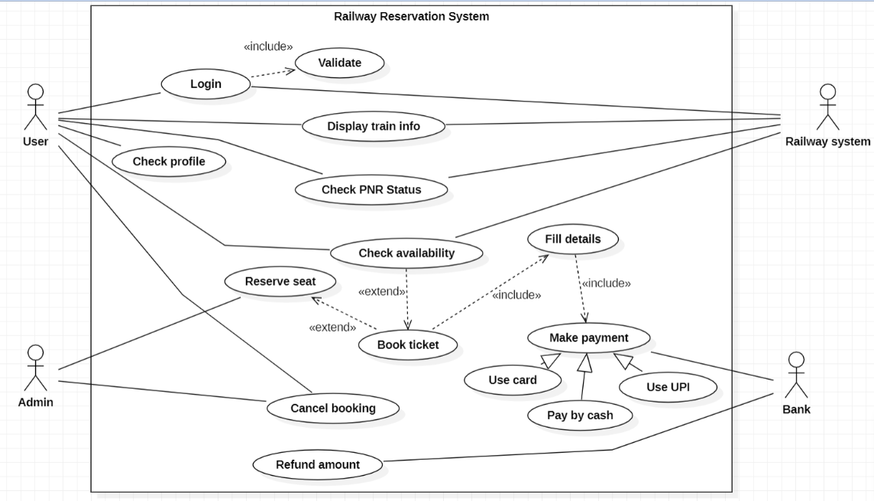

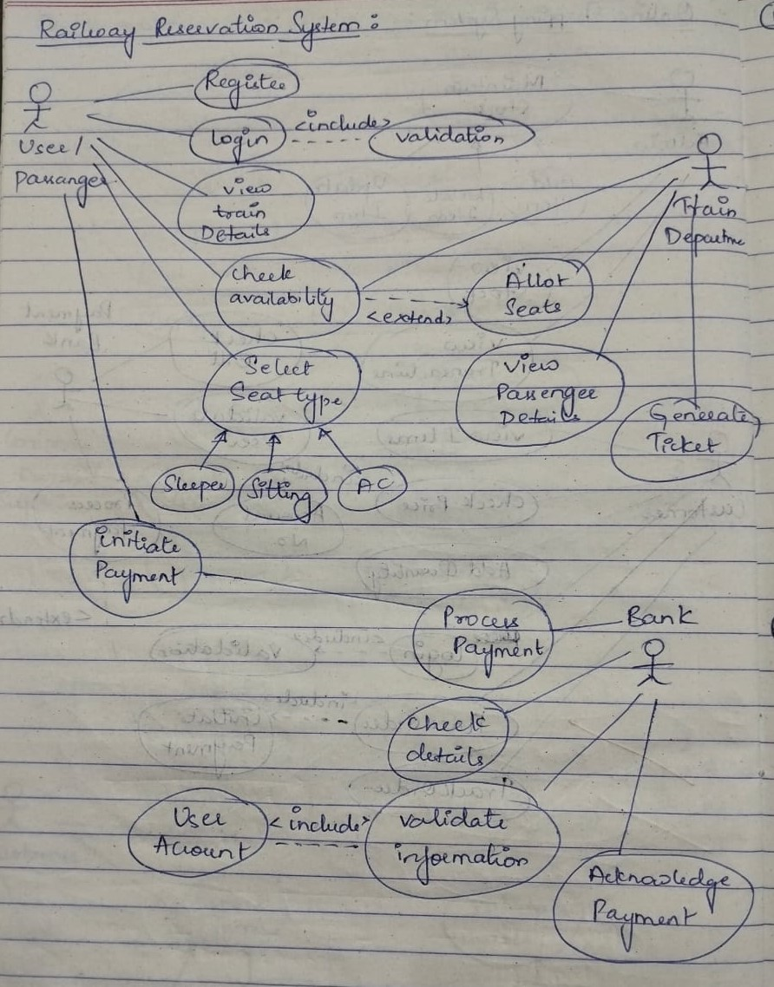

Advanced Sequence Diagram of Railway Reservation System

The lifeline is the dotted line and the rectangles represent the period of time the object is executing

and is hence called activation.

The recursive function of validation is shown by double activation rectangle of validation with self

transition and verify user.Reply message is used to to return back to lifelines with the required

message.

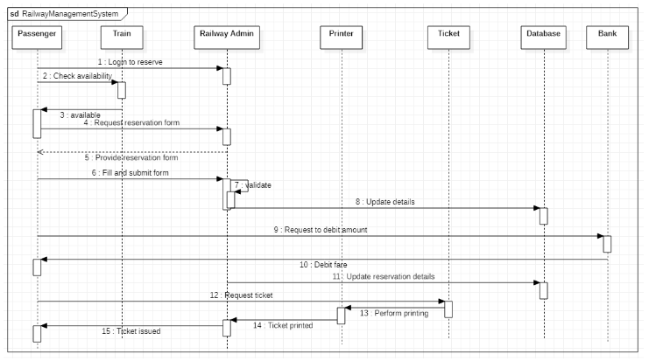

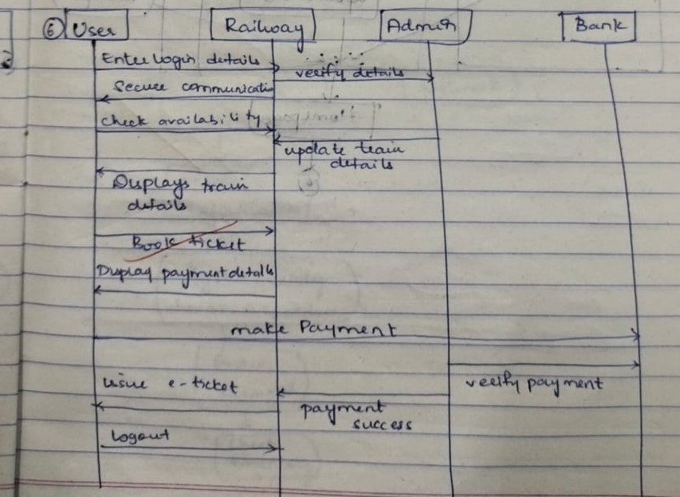

Advanced Activity Diagram of Railway Reservation System

The advanced activity diagram starts from initiation and in the passenger swimlane, the passenger

login activity where a signal is sent to the network for request validation and upon confirmation the

control flows to check seat availability activity. There are four swimlanes namely passenger,

railway63database, railway authority and bank where each one indicates the passenger operations.

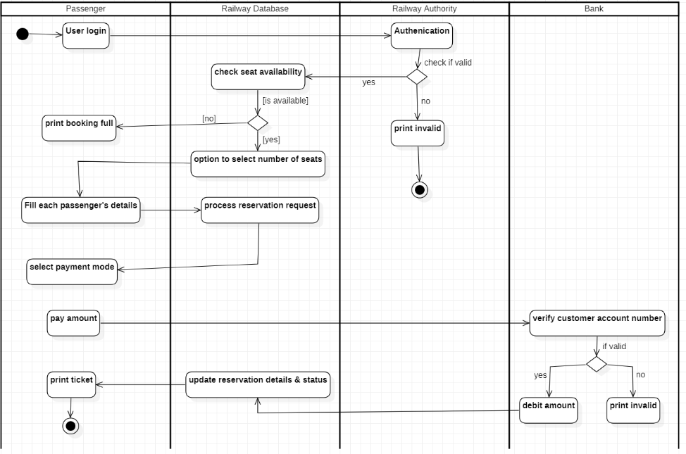

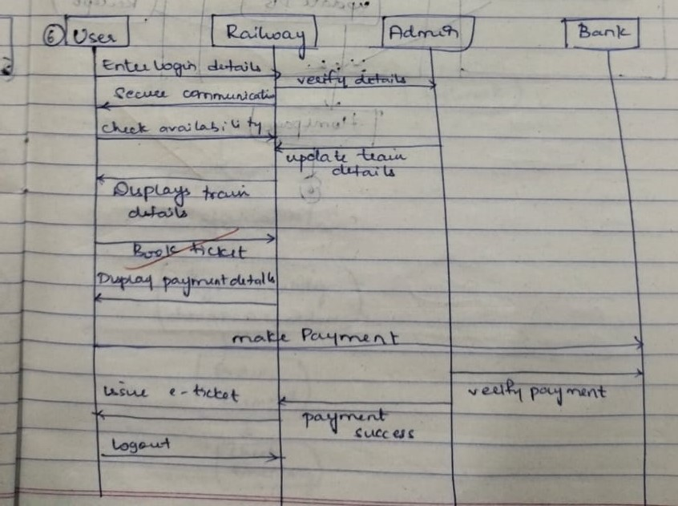

LAB 7

Graphical Editor

**Problem statement:**

Design UML diagrams for Graphics Editor with system requirements specification.

**Software Requirements Specification (SRS):**

The graphics editor provides an Application Programmer’s Interface that enables a programmer to

develop their own graphical model editor for a specific type of model. This API in turn, relies on

extending the Eclipse Graphical Editing Framework to provide an environment in which the editor

functions, and the programmer can create a graphical editor and palette of shapes in order to modify

an underlying model. The graphical editor provides an interface with which the programmer

Implements said editor for a given underlying model. Such an instance of the graphical editor allows

a user to drag objects from a specified model into a working graphical diagram.

It should support following functionalities:

• It contains the toolbox which contains tools like: Line, Circle, Rectangle, Arc,Text, Draw,

Eraser

• Color box or palette

• Standard toolbar with options for New, Open, Save, toolbox and Text Toolbox.

• One integrated view to users for toolbar, color box, menu, and graphic screen.

• Easy handling of tools for users.

• Ability to group several drawings into one i.e., complex drawing.

• Provision of zoom in and zoom out.

• Different shadings of line tool are provided

Advanced Class Diagram of Graphical Editor

The below shown class diagram contains the following classes: GraphicEditor, Document, Sheet,

Group, Object, Text, ZeroDimension, OneDimension, TwoDimension, Point, Line, Arc, Circle,

Rectangle, Ellipse with multiplicities as shown.

Generalization: Text, ZeroDimension, OneDimension, and TwoDimension are generalized to

Object class. Point is generalized to ZeroDimension, Line and Arc are generalized to

OneDimension, Circle, Rectangle and Ellipse are generalized to TwoDimension.

Composition: GraphicsEditor madeof Document, Document containsOf Sheet, Sheet has Group,

Group has Object.

Enumeration: Point

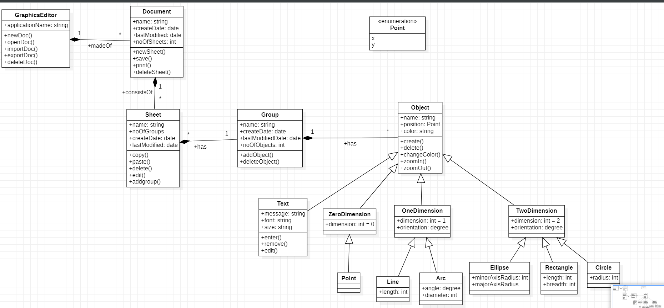

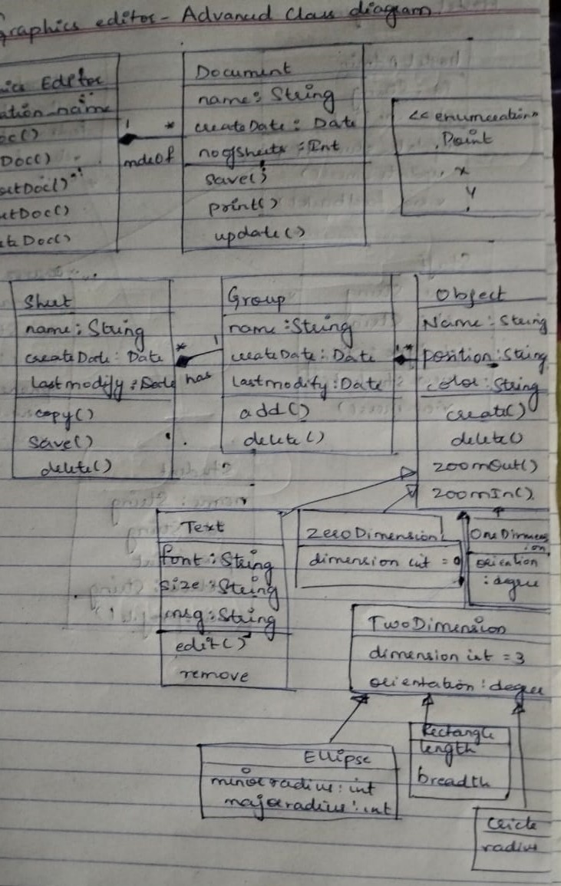

Advanced State Diagram of Graphical Editor

The advanced state diagram depicted below contains one nested state and one submachine, which

on successful login shows the Saving procedure and DrawingSystem procedure. It contains initial

state and termination state with Saving as a nested state including the required simple states. It also

has a submachine state named DrawingSystem with initial, termination state along with simple

states; Shapes, Display and format each shape.

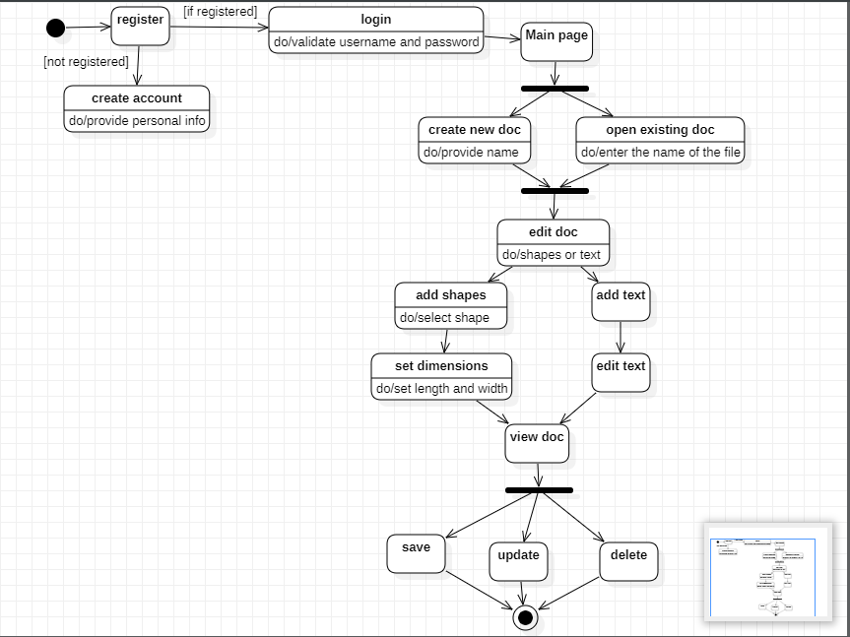

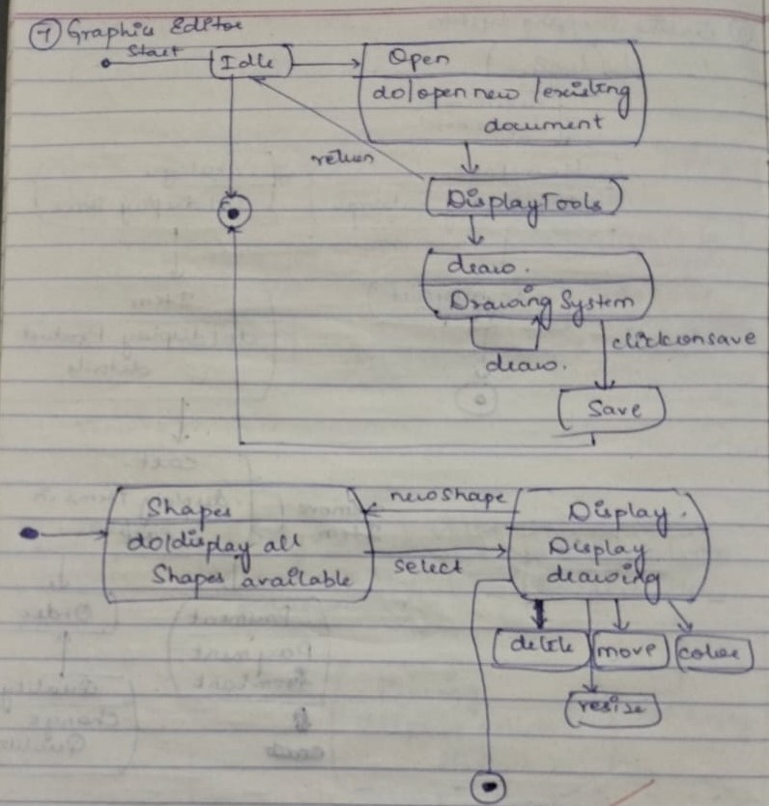

Advanced Use case Diagram of Graphical Editor

The advanced use case diagram has extra functionalities which includes extends, includes and

generalization. The edit document use case extends new document use case, delete document use

case extends new document use case, graphic tools use case extends new document use case, new

document use case includes save document use case. Insert, delete and color is generalized to super

class graphics tools

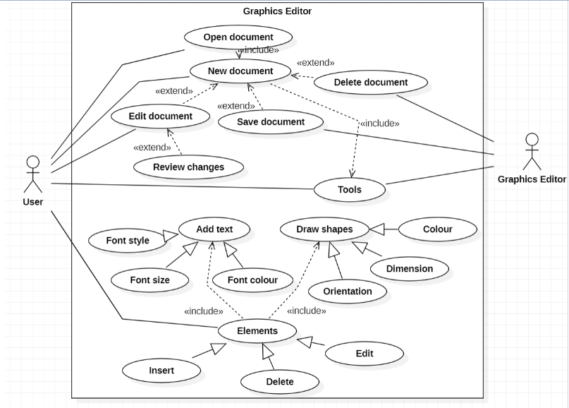

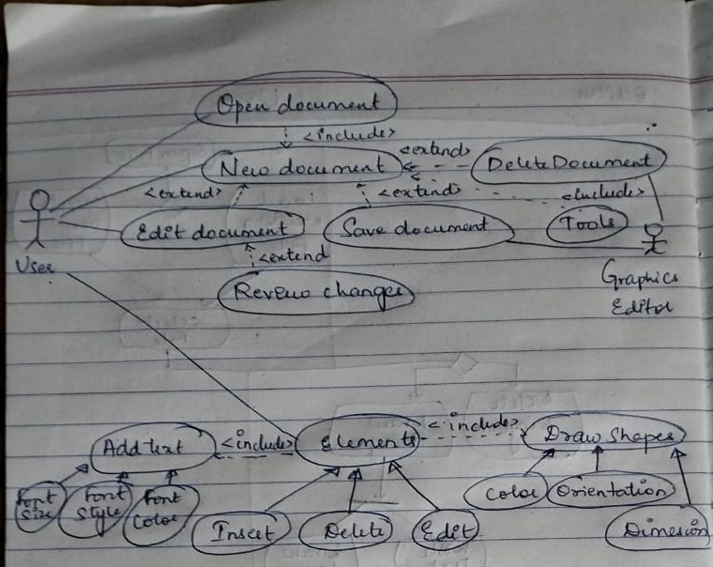

Advanced Sequence Diagram of Graphical Editor

The lifeline is the dotted line and the rectangles represent the period of time the object is executing

and is hence called activation.

Reply message is used to to return back to lifelines with the required message

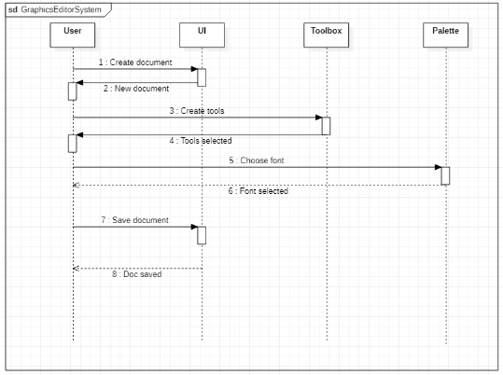

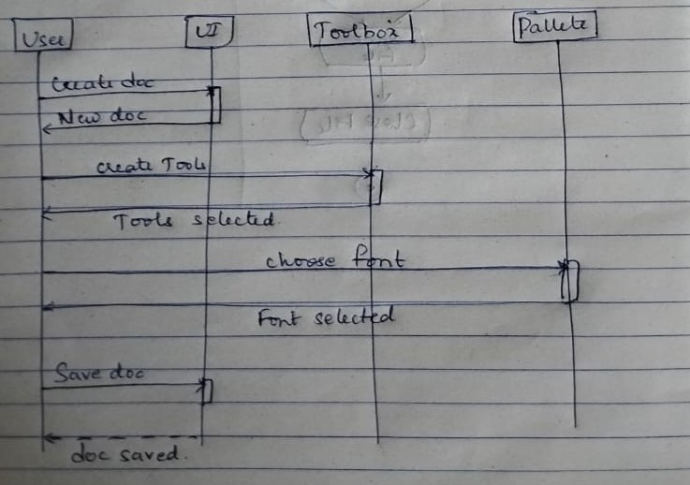

Advanced Activity Diagram of Graphical Editor

The advanced activity diagram startsfrom initiation and in the user swimlane, the user login activity

where a signal is sent to the network for request validation and upon confirmation the control flows

to open file activity. There are two horizontal swimlanes namely user and editor where each one

indicates the user operations and drawing a diagram respectively. Then the control flows to the

close file activity and then termination activities.

